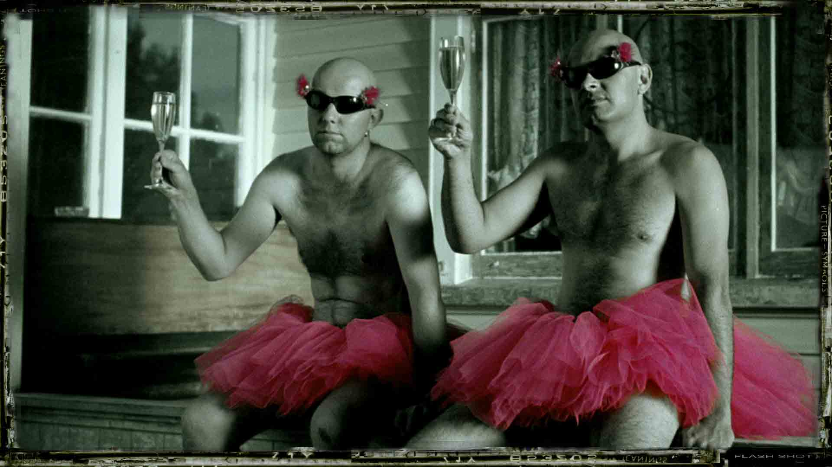


a silent short film about a young male prostitute in a small New Zealand town.

pRESsKiT

INTERNATIONAL SALES

Juliette Veber - NZ Film - PO Box 11 546 - Wellington - New Zealand
Tel +64 4 382 7686 - Fax +64 4 384 9719 - juliette@nzfilm.co.nz

Essential information

Writer/Director: Welby Ings
Producer: Nic Finlayson
Production Company: Room 8
Technical Information: 35mm/ Digibeta / 1:1.85 / Dolby Digital or Dolby SR
Running Time: 14 minutes 58 seconds
Country of Production: New Zealand
Date of completion: May 2004
Genre: short film. fiction
Sales Juliette Veber, New Zealand Film
email juliette@nzfilm.co.nz Tel: +64 4 382 7686
Log Line

getting even is best kept quiet
short synopsis (25 words)
 is an unusual, story of a young male prostitute in a New Zealand village who struggles to expose the truth behind a fatal accident.

long synopsis (up to 200 words)
is the strangely told, silent story of a young male prostitute in a small New Zealand town who discovers the truth behind a fatal hit and run accident.
As news of the death spreads through the district, the family of the responsible driver realizes that the boy must be kept quiet. Using gossip and brutality they set out to frighten him into submission. The pressure becomes increasingly aggressive and through it the boy, from his strange world of broken, angel-like dolls, develops the courage, to expose the truth.
director’s notes

deals with a subject filmmakers tend to avoid. While young, heterosexual men’s emerging sexuality is commonly explored in film and television, their gay equivalent is generally avoided or portrayed as neutral (asexual but camp) or as a victim of paedophilia. Boy is neither. He is a phenomenon in nearly every New Zealand small town with a public toilet.

The story flows as a single, linear thread. The aesthetic references stylistic approaches taken to advertising narratives in New Zealand [integrated colour palettes, editing rhythms and structures]. A significant feature of this approach is the highly condensed nature of the story. The narrative [which might normally be told as a 55 minute drama] is now heavily compressed into less than a quarter of that time. As a result edited sequences average out at 1.2 seconds in duration. The effect establishes an unusually condensed, dreamlike, visually rich form of storytelling that alludes to the world of music video and TVCs but uses these references to develop a very intricate, intensified form of storytelling.
Written words as thoughts, comment on or interrupt developments in the film as fragmented or poetic text. The language in this text is either poetic or references the little known New Zealand bog cruising sub-cultural language of bogspeak or parley. {see ‘other relevant information’).
The sound design is very unusual and has been constructed in such a way as to heighten the sense of dislocation and isolation in the boy’s world. This has been done by stripping out the atmospheric palettes and replacing them with the occasional noise that might normally sit in the background.

director’s bio

Welby Ings is an award winning New Zealand playwright, designer and illustrator. This is his first short film. He is an Associate Professor in Graphic Design at Auckland University of Technology.
Although only released in June of 2004 has already been officially selected for the World Film section of the Montreal International Film Festival, the New Zealand International Film Festival, the 2004 Vinokino International Film Festival [Finland] and the 2004 Mezipatra International Film Festival [Chec Republic].

film website

www.boyshortfilm.co.nz

This site provides downloadable stills from the film. It also features some of the sketches used in the development of the film and updated reviews and screenings of .

production company: room8
producer: Nic Finlayson

Nic Finlayson is a producer, director and camera-man whose work in television documentary, advertising and music video covers ten years of award winning work.
is the first short film where he has operated in the dual role as producer and director of photography.

Other relevant/interesting information

bogspeak

Bogspeak or parley is the language form that appears in scenes where Sam is cruising and in flash shots where he hurls back pictorial insults at the world that has hurt him. Bogspeak a little known language associated with cruising for sex in public toilets in New Zealand. Having origins in thieves’ cant, fairground palarey and the gay polari of the British Merchant Navy, it is a language-form that, while slowly passing from use, is still evident in some rural bog cruising communities.
It is a rich, brutal underground language, colourful in its description and savage in its ability to dehumanize and insult. In the film, it crackles across the boy’s hurled insults at those who attack him and it flickers around his world while he is waiting for tricks in the bogs.

definitions and derivations of bogspeak
appearing in the script

beat noun: 1 public toilets and the surrounding environment where sex between men occurs. The phrase doing the beat is another term for cruising. Beat is particular to both New Zealand and Australia, cottaging is the parallel term in England and tearoom trading is the American equivalent. In New Zealand the word is interchangeable with the older term bog. 2 the space between toilets or sexual encounters.

bitch noun: 1 pejorative (sometimes bantering) term for an insolent, resentful gay man. 2 a man preferring a passive role in anal sex. 3 verb: to complain, nag or criticize. 4 a term for young, spiteful women.

bona, bonar, boner, bono adjective: 1 good. British Polari heavily in use between the 1950s and 1970s. The word bona nochy as a vocative meant good night and bona vardering as an adjective meant good looking. Syn. bonaroo, prison slang- wonderful, excellent. 2 noun: an erect penis. This word was generally spelt boner and appears to have been in more common use amongst non-gay identifying men between the 1960s & 70s, also stiffy. The antonym is naff [not available for fucking].

breeder noun: an unimaginative heterosexual man. The term refers to the propensity for having children. Also Carlotta, het, naff, smeg, SPU [sperm production unit].

cottage noun: public lavatory. Cottage first appeared as a term for toilet at the beginning of the twentieth century. The term was British in origin and generally referred to toilets that were built in parks to resemble miniature country cottages. To go cottaging meant to cruise the bogs/beats.

cruise verb: to look for sex. Although cruise originated in the sixteenth century and was used in connection with the movement of ships, in twentieth century Polari it meant the movement of people. More recently it has come to mean driving or walking around looking for casual sex. The word can also be used to describe the intense, interested way that a man looks at a potential sexual partner. ‘That guy over there keeps cruising me’. Syn. doing the beat, catting, alley catting (late 1960s).

fish noun: a woman. Also cunt, bleeder, double bum, front bum, HRU [human reproduction unit], minge, mullet, three ringed circus, Tina Tuna.

glory hole noun: a hole between two toilet cubicles, normally large enough to poke things through. Larger holes are called blow holes. Smaller holes only large enough to look through are generally termed peep holes or spy holes. These may also appear in a toilet door. The word may have its origins in navy slang. A glory hole referred to compartments on a ship or was used as a word for stewards’ sleeping quarters. Also bosch verb: to drill a glory hole, blow hole or peep hole between two toilet cubicles. In New Zealand this is either done with a pocket-knife and cigarettes or a battery powered drill and a masonry bit. The term may have come from a brand name of a popular power tool.

rent, commercial queen, renter, rent boy, rent queen noun: male prostitute. The word rent was used as early as 1828 to refer to money exchanged for criminal activity. By the 1960s its slang meaning had narrowed to denote gay prostitution and could be used to refer to the prostitute rather than the fee, cf. bona roba (good merchandise, Brit. Polari).
rental box, noun: itinerant male prostitute. The term relates both to the anus and to the rented lockers in New Zealand bus stations where belongings can be stored when one is in transit, cf. iron hoof, merchandise, pro, street mechanic, trader, (dated British slang).

smeg noun: a derogatory term for a heterosexual man. The word is an abbreviation of smegma and refers to the commonly held belief that heterosexual men are not as clean as their gay counterparts. Interestingly in the U.S. in the 1970s it was a description of ‘any unclean dock worker’, (Rogers, 1972:185).
In the Waikato the insult in the 1980s was extended to smegmroni referring to bad heterosexual cooking; Macaroni cheese being seen as the last bastion of culinary atrocity practiced by heterosexuals. Thus, ‘Aghrrr! Smegmaroni’ meaning exceedingly unimaginative.

trade noun: 1 male sex. Trade is broadly a term for a casual sexual partner that dates back to the Molly words of the eighteenth century. It generally refers to an attractive, experienced cruiser. 2 a man who is available for casual sex, normally only allowing himself to be fellated or taking an active role in anal intercourse.
trade curtain noun: a doors on a toilet cubicle (especially in port cities). The use is relatively rare but may have come into bogspeak via U.K. Merchant Navy slang. Because sailors sometimes slept eight to a berth, in order to maintain privacy during sex with other men, they hung a curtain around their bunk.

trick noun: a casual sexual liaison, usually a male prostitute. Also rent boy, renter, rent piece, school bag.

=====================================================================

about the production

was filmed on 35mm film, and uses the HD format for all intermediate stages of post-production. The principal photography was completed within a week from 20-24 January, 2003 at locations in the south Waikato of New Zealand. Two later sequences, including titles and blue-screen elements were filmed in Arapuni and in Auckland respectively. These extra sequences were shot during the period of the offline edit, which meant we could be certain of the styling required. Post-production on the film took four months as much of the digital intermediate process was very exacting as it profiles a highly coloured style with large composite and graphic elements.
The film was then taken back to 35mm print for projection in cinemas [1;1.85] with a Dolby mix soundtrack, however. It is also available on Beta SP [16.9 letterboxed] and DVD [PAL].
The unusual and distinctive sound design has been very important, as the film has no dialogue. The approach has been to communicate aurally the isolation and disconnection that surrounds the main character’s world. The treatment has involved stripping back the most obvious sounds and heightening small details, so they draw attention to the tension in the film. The foley work has been supported by two versions of the song, ‘Anchor Me’, by Don McGlashan and a 17th century Russian choral work, Behold the Bridegroom Cometh.
Performance rights for all three pieces of music have been secured. [Behold the about

Awards:

2004 Honorary Mention-Jury Prize- Mezipatra International Film Festival
2005 Winner-Best Short Narrative Film- Cinequest Film Festival
2005 Winner- Audience Award- Best Experimental Short Film- Planet Out Awards, USA
2005 Winner- Best Short Film, Out Takes Gay & Lesbian Film Festival [New Zealand]
2005 Winner- Best Film, Best Director, Best Art Direction, Best Editing- Drifting Clouds Film Festival [New Zealand]
2005 Winner Best Film Berlin Short Film Festival [Interfilm]

festival screenings:

2004 Montreal World Film Festival
2004 New York International Film Festival
2004 New Zealand International Film Festival
2004 49th Cork Film Festival
2004 Verzaubert 14th International Queer film Festival Germany.
2004 Tirana International film Festival [Albania]
2004 Mezipatra International Film Festival
2004 Reeling Chicago International Film Festival.
2004 Vinokino Film Festival [Finland]
2004 Hamburg Lesbian and Gay film festival
2004 Rozedag film festival [Holland]
2004 Uppsala International film Festival [Sweden].
2005 Clermont-Ferrand International Short Film Festival, France
2005 Common Wealth International Film Festival
2005 Miami Lesbian & Gay film festival
2005 Cinequest [San Diego]
2005 Turin International Gay & Lesbian Film Festival
2005 19ième Film festival [Brussels]
2005 Richmond road film festival
2005 Lyon-Villeurbanne short film festival
2005 Sonar international Film Festival [Florence]
2005 Newport Film Festival
2005 15th Skeive Film Festival, [Oslo]
2005 OUTTAKES Festival [New Zealand]
2005 IndieLisboa Int. Independent Film Festival
2005 Inside Out Toronto Lesbian & Gay Film Festival
2005 Philadelphia Lesbian & Gay Film Festival
2005 Perth International Film Festival
2005 Vienna independent short film festival
2005 17th NEWFEST New York
2005 St Petersburg International short film festival “Message to Man”
2005 Durban International Film Festival
2005 Copenhagen Lesbian and Gay Film Festival
2005 Brisbane International Film Festival
2005 Real Fantastic Korean Film Festival
2005 Louis Le Prince retrospective Film Festival
2005 FilmOut San Diego Film Festival
2005 Paris Lesbian & Gay Film festival
2005 Sao Paulo International Film festival
2005 Rhode Island Film Festival
2005 Palm Springs International Short Film Festival
2005 IMAGE+NATION Queer Film Festival Montreal
2005 Reel Affirmations/One In Ten Film Festival, USA
2005 Drifting Clouds Film Festival, USA
2005 St Tropez Antipodean Film Festival, France
2005 Tabor International film festival [Croatia]
2005 InsideOUT Toronto lesbian and gay film festival
2005 Taipei Golden Horse Festival, Taiwan
2005 Kyiv International Film Festival [Ukraine]
2005 19th Int’lBraunschweig Film Festival
2005 Interfilm Berlin Short Film festival
2005 Seagate Foyle Film Festival, Ireland
2005 Artsfest South Waikato, New Zealand
2005 Rio de Janerio International Short Film Festival [Curta Cinema]
2006 Melbourne Queer Film Festival, Australia
2006 Mardi Gras Film Festival, Australia
2006 Interfilm Berlin Film Festival – Shorts Attack, Germany
2006 Berlin Poetry Film Awards, Germany
2007 Film Festival Salento Finibus Terrae, Italy

Key crew

Written by WELBY INGS

Directed by WELBY INGS

Produced by NIC FINLAYSON

Production Designer WELBY INGS

Sound Designer TOM MISKIN

Director of Photography NIC FINLAYSON

Music Composer DON McGLASHAN

Soundtrack DON McGLASHAN
ANDREW DUBBER

Cast

Sam, Jesse Lee
Driver, Bryan Bevege
Delwyn, Tammy Warwick
Grandmother, Francie Gray
Hitchhiker, Miriam Bleakley
Skinheads, Mathew Risbridge
Paul Probine
Policeman, Bill Taua
Twins, Rebecca & Emily Horgan
School boys, Fredd Marshall
Daniel Hodson
Minister Robert Jenkinson
Sam as a child, Darion Ings
Muzza, Melvin Te Wani
Hitch hiker’s mother Trisha Waugh
Hitch hiker’s, father John ten Velde
Driver’s wife, Amanda Macek
Driver’s son, Luke Thompson
Teacher, Michael Easther
School girls, Hannah Hurst
Stephanie Jefferson.

Crew
First AD Katie Tate
Production Manager Zara Hayden
Gaffer Mark Mateo
Best boy Ben Freedman
Props Rihari Taratoa;Bannister
Mike Holland
Make up Noeline White
Cath Mish-Wills
Wardrobe Yvonne Stewart
Wardrobe Assist Amanda Stewart
2nd AD Katie Flanigan
Production Assistant Tania Ludlow
Focus Pullers Bryony Mathew
Ben Freedman
Clapper Loader Lucy Bowey
Grip Kim Worthington
Lighting assistants Spencer Locke-Bonney
Ben Freedman
On-set Art Rihari Taratoa-Bannister
Art dept assistant Mike Holland
Hair Nyssa Brocklehurst
Loretta Whalley
Aaron Whalley
Unit Suzanne Ings
Carmine Barton
Catering Lois & Arthur Ings
Jeannette Kay
Documentary James Nicholson
Stills K T Ho
Telecine IMAGES POST

Sound Mix and Tracklay INSIDE TRACK

Dolby Sound Mix Chris Burt

Laboratory INSIDE TRACK

Flame artist/editor Brenton Cumberpatch

Typographer & titles Marcus Ringrose

Grading Andy Clarkson
Paul Lear

equipment suppliers

Panavision
Kodak
Lighting Equipment Flashlight, Gordy
Grip Equipment Dolly Shop,
Film Lab Craig Howard
Hollywood Props
Radio Rentals Wendy Maloney

contacts

Director: Welby Ings
Contact address: 172 Opanuku road, Henderson valley. Auckland, New Zealand
Tel: (home) 64-9-8149368 (work) 64-9-9179999 ext. 8621 (fax) 64-9-9179916
Email: welby.ings@aut.ac.nz

Producer: Nic Finlayson
Production company: Room8 ltd.
Contact address: 24 Moira st, Ponsonby, Auckland, NZ.
Tel: 098466769 (home) 021 970169 (work) 098466899(fax)
Email: nic@room8.co.nz

