THE HOPES & DREAMS OF GAZZA SNELL
PRODUCTION NOTES

CONTENTS

2 Fact Sheet
3 Synopsis
4 - 7 ABOUT THE FILM
8-13 ABOUT THE PRODUCTION

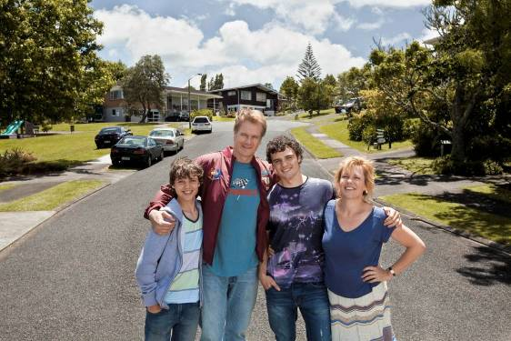
14-18 ABOUT THE CAST
14 William McInnes plays Gazza Snell
15 Robyn Malcolm plays Gail Snell
17 Joel Tobeck plays Ron
18 Josh McKenzie plays Marc Snell

19-24 ABOUT THE FILMMAKERS
19 Director/ Writer Brendan Donovan
20 Writer David Brechin-Smith
20 Producer Robin Scholes
21 Director of Photography Tristan Milani
21 Production Designer Phil Ivey
22 Costume Designer Kirsty Cameron
22 Editor Chris Plummer
23 Composer Mario Grigorov
23 Stunt Co-ordinator Mark Harris

24 CAST & CREW CREDITS LIST

FACT SHEET

The Hopes & Dreams of Gazza Snell

Production company: Eyeworks Film in association with New Zealand Film Commission, NZ On Air and TV3

Producer: Robin Scholes (Once Were Warriors, Broken English, Rain)
Director: Brendan Donovan (Insiders Guide to Happiness [and Love], Aftershock)
Writers: Brendan Donovan and David Brechin-Smith (Insiders Guide to Happiness [and Love])
DOP: Tristan Milani (Balibo, The Boys)
Editor: Chris Plummer (Boy, Dean Spanley)
Designer: Phil Ivey (District 9)
Composer: Mario Grigorov (Precious)
Costume: Kirsty Cameron (In My Father’s Den)

Key cast:
William McInnes (Unfinished Sky, Look Both Ways, Seachange)
Robyn Malcolm (Outrageous Fortune)
Joel Toebeck (30 Days of Nights, Little Fish, Eagle vs Shark)
Josh Mckenzie (introducing)

Distributor: Rialto Distribution
Contact: Adria Buckton, Trigger Marketing & Publicity
SYNOPSIS

A film about an ordinary, infuriating, charming, obsessive, suburban dad who, finally, grows up.

Meet Gazza Snell: entrepreneur, kart club president, and Man About Howick. His obsession with his teen boys’ karting careers has alienated his wife and pushed his family to the financial brink. And yet he smiles through it all, equal parts Charmer, Great Dad, and Frustrating Bastard. You probably know a guy just like him . . . Gazza’s world is turned upside down when his boys collide on the track, forcing him to fight to keep his dreams afloat, and his family together. THE HOPES & DREAMS OF GAZZA SNELL is a father’s coming of age - about letting go and finding something much stronger to hold on to.

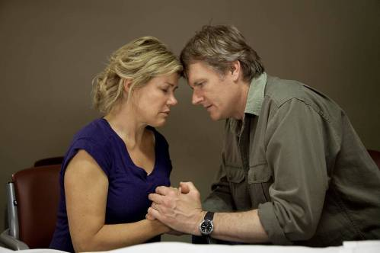
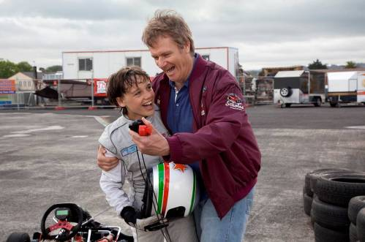
Starring William McInnes (Unfinished Sky, Look Both Ways, Seachange)as Gazza, Robyn Malcolm (Outrageous Fortune) as his wife Gail, Joel Tobeck (30 Days of Nights, Little Fish, Eagle vs Shark) as his old mate Ron and introducing Josh McKenzie as his eldest son, Marc.

ABOUT THE FILM
THE HOPES & DREAMS OF GAZZA SNELL is a coming of age drama with a difference: it’s the father who does the growing up.
In equal measures charming and infuriating, Gazza Snell (William McInnes) is mad about karting – as are his teenage boys Marc and Ed, played by talented newcomers Josh and William McKenzie, who are brothers in real life.
Gazza is obsessive to the point of tunnel vision about his boys making the big time in the world of motorsport. Both boys are talented kart drivers and a lucrative career in Formula One is a real possibility. Gazza has borrowed big money, is on the verge of securing a job with a local Chinese businessman and is hopeful the next race will get Marc a spot with an elite Italian training team.

It’s a passion reluctantly accepted by their mother, Gail (Robyn Malcolm). She loves Gazza and the boys, but often feels like an outsider in her own family. She finds herself relying on family friend Ron (Joel Tobeck) for things like keeping her rundown old car on the road.

Then the boys collide on the track. Marc is unhurt but Ed is in a coma. Gazza’s life is turned upside down, Gail’s worst nightmare has come true and Marc believes it was all his fault. And so begins a journey that will tear the family apart and change Gazza’s life forever.
Australian William McInnes, who won an AFI Award for his recent film Unfinished Sky, and who was given the Sydney Morning Herald/Sun Herald/The Age Australian Star of The Year Award in 2006, heads the strong cast as the infuriatingly lovable bloke Gazza. Robyn Malcolm, also an award winner, and a household name in New Zealand through her immensely popular roles as Cheryl West in Outrageous Fortune and Ellen Crozier in Shortland Street, joins him as Gail, Gazza’s long-patient wife. Australian-based kiwi actor Joel Tobeck (30 Days of Nights, Little Fish, Eagle vs Shark) plays Ron, Gazza’s best mate and the film introduces Josh McKenzie as Marc Snell.
Director Brendan Donovan, who also co-wrote the script, says the title is self-explanatory. “It really is the hopes and dreams of Gazza Snell. It’s what he hopes, and what he dreams of for himself and for his family and how those hopes and dreams become altered over the course of time.
“They’re an ordinary family. Although Gazza would never see himself as that – he would see himself as extraordinary and he would see his boys as extraordinary and his wife as extraordinary.
“I think it’s possible for people to change and Gazza does change. It’s the story of his coming of age. He finally grows up and hopefully the audience will come out with a sense of optimism and hope.”
William McInnes says Gazza is a character that’s rarely seen in New Zealand films and yet he has qualities that are commonly thought of as New Zealand traits. “He’s a lower middle class scrapper. He’ll get up and have a go. He’s straight up and down. He thinks he can sell anything and have a crack at anything. That idea of endeavour is really strong in people’s view of New Zealanders: that you’ll just get on with the job and you’ll get it done.
“And in getting on with life, Gazza just bypasses life - he doesn’t stop to take it in and appreciate what he’s got. So he’s always chasing a dream.
“I think that may be a thing that men tend to do. You detach yourself from certain points of your life while you get on with others. It’s not unknown for men to work too hard and play too hard and then realise that the family’s going in another direction without them. It takes this accident for Gazza to realise that.”

However, “It’s a film that's being made to be enjoyed as an entertainment. It’s an affirming film which doesn’t preach.”
Robyn Malcolm describes her character, Gail as “the classic ballast of the family. Gazza’s the dreamer and Gail is the realist and through their married life. Those roles are challenged during the story of the film. The grief and the fear that both parents deal with upend those roles.
“The Snells are a very normal kiwi family. You see them at any barbecue - the dad is the life and soul around the barbie and Gail’s in the kitchen chopping up the coleslaw. They’re fully part of the community, they’ve got two great boys and they’re a pretty straightforward kind of family. And then they’re hit by a tidal wave, something out of the blue, which is deeply tragic and frightening. I think what’s clever about this story is that it’s not death they’re hit with. They’re hit with the fear of death, and it’s the fear of the death of a child, which I think is very profound.”
Producer Robin Scholes says THE HOPES & DREAMS OF GAZZA SNELL being an intimate drama about a man and his emotional crisis is a departure for the largely female audience the film is targeting.
“I’m really proud to be associated with a film that features a male story because most films for this particular audience are about women. This audience likes intelligent, emotionally-driven character drama and this fits in that mould, but often these films are driven by female characters.”
THE HOPES & DREAMS OF GAZZA SNELL is directed by Brendan Donovan, who also wrote the script with David Brechin-Smith (Insider’s Guide). It is a first feature for Donovan, who has written and directed several short films including the award-winning Here. He was the lead director on the acclaimed Insider’s Guide to Happiness and Insider’s Guide to Love, for which he won a Qantas best director award. His other television drama work includes disaster tele-film Aftershock, which earned him another Qantas best director award.
THE HOPES & DREAMS OF GAZZA SNELL is an Eyeworks film in association with New Zealand Film Commission, NZ On Air and TV3. Australasian distribution is by Rialto, distributor of box office hit Topp Twins: Untouchable Girls. International sales are handled by NZ Film.
Executive producers are Julie Christie and Simon Millar and producer is Robin Scholes (Once Were Warriors, Rain, Broken English). Director of photography is Tristan Milani (Balibo, The Boys), production designer Phil Ivey (District 9, Perfect Creature), costume designer Kirsty Cameron (In My Father’s Den, Perfect Creature), editor Christopher Plummer (Boy, Dean Spanley) and the composer is Mario Grigorov (Precious).

Producer Robin Scholes says this film, like many recent productions, is funded entirely from New Zealand sources, including the NZFC, the Producer Rebate, NZ On Air, TV3 and local distributor Rialto.

“The rebate is a really important core source of funding local films. Without it we would never get to make films which have a unique New Zealand voice. It’s vital to have something like this rebate because the local industry would find it very difficult to fund films which are culturally unique and without them we would be a much poorer culture.”

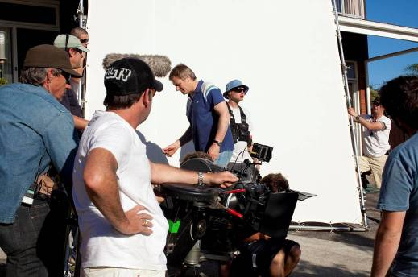
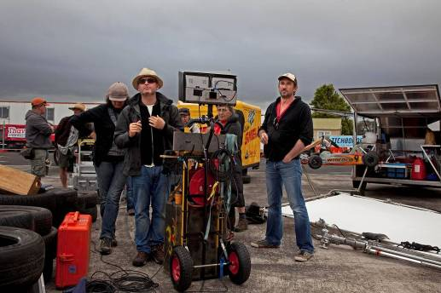

ABOUT THE PRODUCTION

Director Brendan Donovan says the story originated when he was looking at a possible location for a television commercial and came across a man whose house was full of karting equipment and memorabilia.

“The guy was massively into karting and so were his sons and he was running a small business from home. Although I didn’t know anything about karting, I just saw this as a fantastic microcosm in which to play out a bigger story”.

He was thinking of a story about an ordinary family under pressure:
“I enjoy films where great pressures are exerted on people and I was really fascinated by this idea of exerting great pressure on this family and seeing whether they coped and whether they came through it or not.”

He was also interested in reflecting the social changes occurring over the past 10 years in his home suburb of Howick in East Auckland.

“In 2002, I came back from New York after being way for about eight years and Howick had changed radically. The Chinese, Koreans and Hong Kongese had landed in Howick and it was radically different, which I found fascinating. But the suburb was still struggling with the pace of change when I first arrived, so that interested me as a possible thematic thread.”

In early drafts the story had a cross-cultural Romeo and Juliet-style teen romance at its heart, but Donovan says it evolved in a different direction.

“Gazza just stuck his head out of the crowd and said ‘I’m the most interesting character here’. So we started structuring the story more and more around him until it became a coming of age story for a father set in the texture of this world that is half-European, half-Chinese and with his obsession with karting, which was the thing he has to leave in order to reconnect with his family.”

Donovan says he found the perfect Gazza with the casting of William McInnes: “I think William actually is partly Gazza. He brings a really strong sense of personality. He’s got a really great emotional truth to his acting and there’s a lot of intense emotional acting required in this piece. He’s got a real presence, a real charisma. He’s funny and yet he also can be very hard and that’s Gazza.”

He had asked Robyn Malcolm to do a read-through about two years before the shoot. “I had always seen Robyn in that role and she was fantastic in that read through. I wanted a kind of quiet strength from the actress for this role and she brought a very controlled, delicate, softer strength.”

Josh McKenzie, who plays Gazza’s older son Marc, is the big discovery of this film, which he shot just before going to Toi Whakaari New Zealand Drama School. Donovan says, “Josh is a young Brando. He’s just beginning his acting career but he’s prepared to give himself totally the work and he had a real emotional honesty in his performance.”

He says it was a great advantage to be able to cast William McKenzie as Ed, Gazza’s youngest son, since he is the younger brother of Josh in real life. “If you can cast brothers as brothers it’s incredible because it adds a dimension of emotional reality. William has a real charming beautiful vulnerability in his face and we really wanted the audience to just feel ‘oh my goodness can’t lose Ed’.

Scholes says, “Initially we were worried that people who were inexperienced would take time to learn the craft and get up to speed, but these two have been wonderful. I believe that Josh is destined for a big film career in film. He’s extraordinary.”

Josh McKenzie says it was very helpful having his real younger brother in the Ed role, “especially the hospital scene. Seeing him in a coma brings the tears out.

“It’s definitely helpful to establish that family bond because you don’t have to learn to get intimate with each other because you already are. You know you can give them a kiss or a hug and not feel a bit weird about it so it’s more comfortable working with them.”

THE HOPES & DREAMS OF GAZZA SNELL was filmed in the suburb in which the story is set: Howick, in East Auckland. Donovan says he set the story in Howick because of its rapidly-changing ethnic composition – the gap between the new and “old Howick” - and also because it’s the place he knows best. “I lived there since I was three, my mother has been there since she was about 16 and my grandparents were there for years.”

He also says that most of the extraordinary things that happen to people, the things that put them under emotional pressure, tend to happen where they live.

“Most people live in the suburbs and most often major drama is going to happen to them where they live and work. Gazza lives and works in Howick, a suburb. This intense, massive event happens to his family in this suburb and that’s why we filmed in the suburb - in his house, in his mate’s house, at the car club, at the hospital. These are the places in which we would normally be living our lives. We’re not suddenly on some other planet.”

Producer Robin Scholes: “A drama these days has to have a big character story but it also needs to be set in a world which is entirely unique, so the audience have an entry into something they would never normally experience.

“Brendan is the key to the audience entering into this unique and different world, because he grew up in Howick, then he went away and came back and is telling this story which is set in his home turf and relies on characters that he knows well.”

Production designer Phil Ivey says Donovan’s local knowledge was invaluable when it came to location scouting, since they filmed in existing buildings for every scene except the bathroom, which they built as a set.

“This film has really believable characters, and as soon as I read the script I could picture where they lived, especially after taking a tour with Brendon. He knows the place like the back of his hand and he took me for a long drive, showing me his world.

“It’s a story we can all relate to, since most of us grew up in the suburbs, and you often hear of things like this happening. I have three children and I relate to it as a drama about a family who are experiencing every parent’s worst nightmare – one of their children being seriously injured and the possibly of having to turn off their life support.”

Another part of the project’s appeal to the designer was its location: “East Auckland is an area of Auckland which hasn’t been shot very much and Howick gave us a good range of architecture from the 1960s bungalow that the Snells live in through to Ron’s 1970s architectural house, through to the Lin’s mansion in new subdivisions being built by the Chinese community.

Director of photography Tristan Milani says: “I was attracted to the film because at home in Australia I’m known - Variety magazine said I was the ‘Aussie domestic drama ace’. I'm really interested in suburban stories and I’ve done them all my life. My first film The Boys was a domestic drama and I'm really drawn to the suburban condition. This suburb, particularly the way it’s changing, is fascinating - the cultural change as well as the geographic change in a traditional New Zealand suburb - I think that’s a really interesting conflict.

“When I first talked to Brendan Donovan, he had a very clear view of what he wanted visually and the words he used were ‘epic intimacy’. The film is set in Howick, which has a very distinctive look and it’s a suburb that’s changing. He wanted to realise that change visually and so we decided to shoot the film in wide screen to and make Howick a character in the film.”

The production company built a kart track at the old Hobsonville Airbase in Waitakere City. Designer Ivey researched existing tracks and designed the purpose-built one on which to film the racing action scenes and the kart crash.

He says because they had to do it as cheaply as possible, they had to find the right location and bring in the elements - barricading, grandstands, signage, concession stands etc.

“It was thoroughly enjoyable. It’s not every film you get to design a racetrack and the kart drivers seemed to love it. They couldn’t wait to get out there and we couldn’t keep them off it, so I think we were pretty successful.

“Fortunately for us, New Zealand kart tracks are quite low-fi. There’s not a lot of signage, not a lot of sponsorship, so it was a case of trying to keep it as real as possible - not jazzing it up and turning it into Days Of Thunder - keeping it kiwi, keeping it real.”

Stunt co-ordinator Mark Harris, who has a background as a rally driver, drove a kart for the first time during the shoot and notes the differences: “The sensation of speed is intense, karts get up to their maximum speed so fast and you’re about one inch off the ground, so it feels like you’re going three times faster than you are and they’re just so responsive. There’s an awful lot of skill in it. People think of go karts as a toy, but they’re definitely not a toy, they can do 200 kilometres an hour and get there in seconds. They’re insanely quick. The only thing that can beat them is Formula One.

“If I was going to get my kids into motorsport it would be karting. It’s relatively cheap in comparison to most of the other motor sports and there’s a big family thing around it. I can see the attraction.”

His biggest challenge was the kart crash, which had to look severe enough to give Ed, the young driver, head injuries, and yet to look as if he could have come out alive, while at the same time being possible to carry out safely for the cameras.

“We decided to go remote control because we couldn’t put a person in the kart because it had to flip down and you can’t put a roll cage in a kart so there’s no protection. It was quite difficult to do remote control on a kart and it was the first time we’ve done it. We had to bring in some robotic equipment from the States and we had Chris Chitty who runs the robotics department at Massey University helping us.”

Harris says he did a tremendous amount of research to assess and calculate the most effective way to carry out the stunt, which depended on being able to get the robo-controlled kart to react in the right way when it crashes into the stunt-driven kart. To achieve this, he had to modify a kart in order to accommodate the robotics and the art department-made dummy driver. They successfully achieved the shot after only five attempts.

Critically acclaimed New Zealand singer/songwriter Miriam Clancy teamed up with the film’s composer, Mario Grigorov, who composed the Academy Award best film nominee Precious, to create a pop-rock song, “Life Extraordinary” for the film’s soundtrack. The song was recorded at Neil Finn’s Roundhead studios by Neil Baldock and features the guitar talents of Jolyon Mulholland (The Motts) and drumming legend Chris O’Connor (SJD, Don McGlashan), with violins from the Auckland Philharmonic and keyboards by Grigorov, The track was mixed at both Roundhead and Peter Jackson’s Park Road Post in Wellington, with final mastering by John Neill at Park Road Post. It was released to coincide with the release of the film.
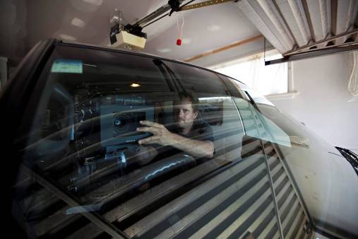
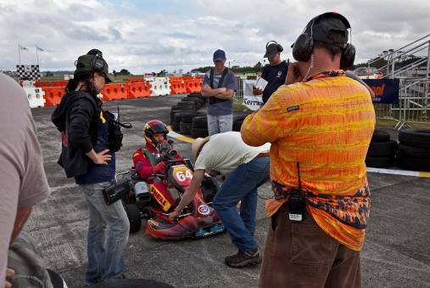

ABOUT THE CAST

William McInnes plays Gazza Snell

William McInnes is one of the most accomplished and popular actors on the Australian landscape today. In 2006 he was awarded the Sydney Morning Herald, Sun Herald and the Age ‘Australian Star of The Year’ Award. Equally at home in theatre, film and television, comedy and drama, he has played countless lead and supporting roles in some of the most successful and memorable productions this country has had to offer and has multiple AFI and Logie nominations for this extensive body of work.

In television, he has shone in dramatic lead roles in The Shark Net, My Brother Jack, Blue Heelers, Stepfather of the Bride, Seachange and in the critically acclaimed and ratings success ABC telemovie Curtin, about Australia’s wartime prime minister, and in the hard hitting SBS television series East West 1-0-1

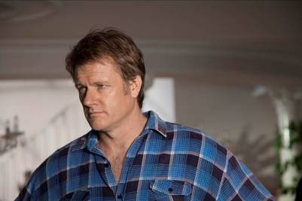
McInnes’ work in Australian cinema is also widely acknowledged, by both industry peers and audience alike. The feature film, Look Both Ways, saw him achieve a nomination for best lead actor by the Australian Film Institute and receive the Film Critics Circle of Australia Award for Best Actor. He also received an AFI Award and a Film Critics Circle of Australia Award for his performance in Unfinished Sky. In 2008, he filmed roles in David Caesar’s Prime Mover and Blessed directed by Ana Kokkinos.

His many lead roles on the stage only further highlight his remarkable career. His performances include Don Juan for Sydney Theatre Company, Macbeth and Ray’s Tempest for Melbourne Theatre Company and Darcy for both companies’ landmark productions of Pride and Prejudice. He recently appeared on stage in My Fair Lady in New Zealand.

He is also the author of two best-selling books: A Man’s Gotta Have a Hobby, winner of a 2006 Australian Book industry award, and Cricket Kings which was a 2007 Australian book industry award nominee. His third book, That’d Be Right has just been published.

Robyn Malcolm plays Gail Snell

Robyn Malcolm is at the peak of her powers as New Zealand’s most-loved actress and The Hopes & Dreams of Gazza Snell gives audiences a chance to see another dimension of her acting talents.

At the 2008 Qantas Film and Television Awards, she won the best actress award for her role as Cheryl West in Outrageous Fortune. She was also voted Best Actress for the fourth consecutive year and Sexiest Woman for the second consecutive year in the 2009 TV Guide Best on the Box Awards People’s Choice Awards.

2007 was also a stellar year: she was named Best Actress at the Qantas Television Awards and the Air New Zealand Screen Directors Guild Awards. In the same year, she was voted Favourite Female Personality in the Woman’s Day Readers’ Choice Awards. She also won the TV3 and C4 Success in NZ Television Award at the WIFT NZ Awards 2007. In late 2007, she returned to the stage playing one of the leads in the SiLo Theatre’s production of The Cut.

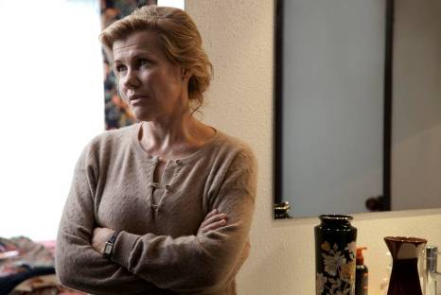
New Zealanders came to adore her when she played Nurse Ellen Crozier on Shortland Street – a role she held for six years and which earned her a nomination for Best Actress at the 1998 TV Guide Television Awards.

In 2000, she played the lead role in Clare, a television feature based on the true story of a woman who took on the New Zealand medical establishment. The role earned her a nomination for Best Actress at the 2002 TV Guide Television Awards.

Around the same time, she returned to her theatrical roots and in 2000, she was one of the founding members of the New Zealand Actors’ Company along with Tim Balme, Katie Wolfe and Simon Bennett. Between 2000-2002, the company produced and toured a number of vibrant and successful stage productions including A Midsummer Night’s Dream (in which she played Titania); Roger Hall’s A Way of Life (in which she played Jenny); and Leah which was featured in the 2002 International Festival of the Arts.

Since then, Malcolm has appeared in a number of other successful television series including the satirical comedy Serial Killers for which she was the winner of Best Performance by an Actress at the New Zealand Screen Awards in 2005.

She has also starred as herself as a panellist in How’s Life and as a host in Intrepid Journeys, a travel documentary series which took her to Vietnam.
In 2005 she traveled to France to front a TV One documentary Our Lost War: Passchendaele about the World War I battle in which her great uncle lost his life.

She graduated from Toi Whakaari: New Zealand Drama School in 1987 and started her career in theatre. Since 1988 she has worked at many of New Zealand’s top theatres and alongside many accomplished local directors. Her extensive theatre credits include: The Threepenny Opera, Macbeth, The Importance of Being Earnest and, more recently, Cat on a Hot Tin Roof with director Colin McColl at Downstage Theatre; Twelfth Night, Conquest of the South Pole and Hamlet, all of which were directed by Simon Bennett at Bats Theatre; Via Satellite, Two Weeks with the Queen and Lettice and Lovage at Circa Theatre; Othello with director Michael Hurst at Auckland’s Watershed Theatre; and Much Ado About Nothing directed by Miranda Harcourt at Downstage Theatre.

In addition to her television and stage roles, Malcolm has several feature film credits to her name, including: Absent without Leave directed by Outrageous Fortune producer John Laing, The Last Tattoo directed by John Reid, Gaylene Preston’s Perfect Strangers, Lord of the Rings: The Two Towers directed by Peter Jackson and Christine Jeff’s Sylvia. In 2008 she also appeared in a guest role in Peter Jackson’s latest feature The Lovely Bones, based on the international best-selling novel by Alice Seabold.

Joel Tobeck plays Ron

Joel Tobeck earned an international fan following with his manic creations, the related characters Strife and Deimos in Hercules and Young Hercules.

Now living in Australia, he has worked in television and film on both sides of the Tasman, including the critically acclaimed Little Fish, Eagle vs Shark, Memory & Desire and Perfect Strangers. Other films include The Lord of the Rings: The Return of the King, 30 Days of Night, The Water Horse, Mee-Shee: The Water Giant and Topless Women Talk About Their Lives, for which he won a New Zealand Film Awards best actor award.

He plays Richard Foster in the upcoming New Zealand television series This is Not My Life and was Tim Williams in the recent Australian series Tangle and Martin Manning in 30 Seconds, also made in Australia last year.
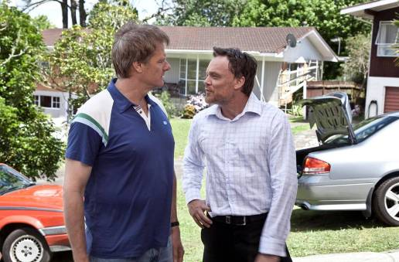
His other television work includes Without A Trace, Xena: Warrior Princess, Cleopatra 2525, Mercy Peak, Power Rangers: Dino Thunder. He was the lead in
Niki Caro's Cannes-nominated short Sure To Rise (1994) and has an extensive career in theatre.
Josh McKenzie plays Marc Snell
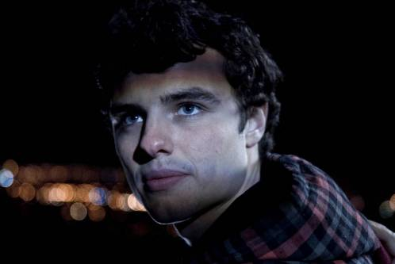
THE HOPES & DREAMS OF GAZZA SNELL is Josh McKenzie’s first professional acting job. It was done in his first year out of secondary school and he turned 19 during the filming. Soon after filming completed he played a major guest role on Legend of the Seeker and then went on to attend Toi Whakaari, New Zealand Drama School in Wellington, where he is currently.

He says he always wanted to be an actor (or a stunt man) and performed in school theatre. Originally from Wellington, he attended St Patricks College in Kilbirnie, before moving to Auckland Grammar School.

ABOUT THE FILMMAKERS

Brendan Donovan, director/writer

Brendan Donovan was the lead director of the critically acclaimed TV series’ The Insiders Guide To Happiness and The Insiders Guide to Love (for which he won a Qantas Television Award for best director).

He directed Aftershock, a tele-film about an 8.2 earthquake destroying Wellington, for which he won a Qantas Film and TV best director [television] award.

He grew up in Howick, and has returned to his roots for his first feature film. From age three to 18 Brendan lived in Cockle Bay. His parents still live there. His grandparents first moved to Howick in the late 1940s.

He was a student at both Howick and Macleans Colleges, and has a BA and BCom from the University of Otago. He worked as a graphic designer in Wellington in the 1990s before moving to New York, where he worked in advertising as a creative director. He then began directing commercials, short films and music videos in America, Australia, and New Zealand. He returned home in 2002 after eight years away.

His debut short Here (2001), made while he was directing commercials in America, featured Lee Majors as an ageing hit-man. His other short films include Grasp and Cockle and his music videos include the single-shot Girl about Town for singer/songwriter Miriam Clancy, with whom he also worked on Life Extraordinary, the lead song in THE HOPES & DREAMS OF GAZZA SNELL.

David Brechin-Smith, writer

David Brechin-Smith won a Qantas best script award for his work on The Insiders Guide to Love and a NZ Screen award for The Insiders Guide to Happiness. He was also nominated for The Strip and Lovebites. His other television work includes The Cult , Paradise Café and Hothouse, for which he was the creator and writer.

Before moving into drama, he wrote scripts for light entertainment and comedy shows including Celebrity Squares, The Gong Show, McPhail & Gadsby and Strassman. He also wrote for the Strassman live show.

Robin Scholes, producer

Robin Scholes is the producer of five feature films: The Tattooist (2007) directed by Peter Burger, a New Zealand- Singapore co-production between Eyeworks Touchdown Films and MediaCorp Raintree Pictures, Crooked Earth (2001) directed by Sam Pillsbury, financed by Pandora and the NZFC, Rain (2001) directed by Christine Jeffs, financed and distributed by the NZFC, Broken English (1996) directed by Gregor Nicholas, financed by Village Roadshow and the NZFC, and Once Were Warriors (1994) directed by Lee Tamahori and sold to over 100 territories, selected for major festivals and a multi-award winner.

She is currently working with Andrew Adamson (Shrek, Narnia The Lion the Witch and the Wardrobe and Prince Caspian) on an adaptation of the Booker Prize short-listed novel Mr Pip by Lloyd Jones. She is also working on an adaptation of Witi Ihimaera’s novel Bulibasha to be directed by Lee Tamahori and co-written by John Collee (Master and Commander, Happy Feet) and Witi Ihimaera.

Scholes graduated from both Auckland and Edinburgh universities and became a lecturer at both Essex University in the United Kingdom and Auckland University in Art History and Film Studies. She then went on to work for TVNZ, writing, directing and producing documentaries and various studio and magazine shows She was a 1980 Fullbright Scholar attending the New York Film School and was awarded an OBE in 1997 for her services to Film.

She has devised a wide range of television series that have provided a solid business base. She was one of the founding partners and executive directors of Communicado, where she produced the documentary and information series Magic Kiwis, Heroes, Business World, It’s in the Bag, Success, Animals and Us, Money, Farmer and New Zealand 2000. Her television drama credits include Greenstone, The Chosen, Homeward Bound and True Life Stories.

After 2001 she continued as a director of the merged Screentime Communicado and devised, executive produced and/or produced a wide range of television programmes including The Big Art Trip, Life Goes On, and Grass Roots Business. She joined Eyeworks in 2005.

Tristan Milani, director of photography

Australian director of photography Tristan Milani shot the acclaimed Balibo, the political thriller about the five Australian-based journalists murdered in East Timor, which was directed by Robert Connolly. He also worked with Connolly on Three Dollars and The Bank.

He shot The Boys, the 1998 R-rated drama of a violent family starring David Wenham and Toni Collette. His other films include Ten Empty, The Book of Revelation, Barely Visible. Travelling Light and Roundabout.

Phil Ivey, production designer

Phil Ivey was production designer on the breakthrough hit District 9 and his other feature film production designer credits include Out of the Blue, Robert Sarkies’ tense thriller about the Aramoana massacre; and No 2, Toa Fraser’s Pacific Island family drama and Glenn Standring’s fantasy-horror Perfect Creature, starring Dougray Scott and Saffron Burrows. He designed the television series Burying Brian, which was produced by Robin Scholes for Eyeworks.

He was supervising art director for the Korean-American co-production Warrior’s Way, and art director for The Legend of Zorro, In My Father’s Den, Boogeyman, The Lord of the Rings trilogy and Xena: Warrior Princess. Before that, he worked as art department props for the Hercules telemovies, Hercules The Legendary Journeys, Mrs Piggle-Wiggle, The Rainbow Warrior and The Sound and the Silence.

Kirsty Cameron, costume designer

Kirsty Cameron won the NZ Film best costume design award in 2003 for Niki Caro’s international success Whale Rider.

Her most recent films are the upcoming After The Waterfall, directed by Simone Horrocks and the recently released The Strength of Water, directed by Armagan Ballantyne. She also designed the costumes for Fiona Samuels’ tele-feature Piece of My Heart, which starred Keisha Castle-Hughes and Emily Barclay.

She also designed costumes for Brad McGann’s adaptation of Maurice Gee’s In My Father’s Den, Glenn Standring’s fantasy-horror Perfect Creature and Christine Jeffs’ drama Rain, which was produced by Robin Scholes. She was production designer and costume designer for Harry Sinclair’s The Price of Milk.

Chris Plummer, editor

Chris Plummer edited the current New Zealand box office smash hit Boy, directed by Taika Waititi. He has an extensive list of credits, including Under The Mountain, Dean Spanley, Black Sheep, No 2, Rain of the Children, In My Father’s Den and Crooked Earth. His most recent film is the upcoming Love Birds, starring Rhys Darby.

His television work includes the series Riverworld, Power Rangers Ninja Storm, Cleopatra 2525 and Jack of All Trades.

Mario Grigorov, composer

Mario Grigorov composed the music for the critically acclaimed Academy Award best film nominee Precious. He also composed for director Brendan Donovan’s early short films Here and Grasp, which is why he worked again with Donovan on THE HOPES & DREAMS OF GAZZA SNELL, for which he composed with Miriam Clancy the lead song Life Extraordinary, which was released as a single.

He recently completed documentaries War Against the Weak and Breath Made Visible. He composed for Tennessee, a drama starring Mariah Carey, the horror thriller The Attic and the crime drama Shadowboxer, starring Cuba Gooding Jr, Helen Mirren and Joseph Gordon-Levitt. He has also composed for many short films and documentaries.

Mark Harris, stunt co-ordinator

Mark Harris, a former rally car driver, has extensive experience as a stunt co-ordinator, stunt performer, precision driver and stunt rigger for feature films including Whale Rider, World’s Fastest Indian, Perfect Creature, Sione’s Wedding and Boogeyman. His television work includes Outrageous Fortune, six series of Xena: Warrior Princess and Hercules The Legendary Journeys, five Hercules telemovies, the Young Hercules telemovie and series, two series of Cleopatra 2525 and the Jack of All Trades series. He has also worked on numerous New Zealand and international television commercials.

CAST AND CREW CREDITS LIST

Cast

Gazza William McInnes
Gail Robyn Malcolm
Ron Joel Tobeck
Marc Josh McKenzie
Ed William McKenzie
Jee Melissa Xiao
Mr Lin Gary Young
Dr Riebeeck Sarah Peirse
Francis Cameron White
Mrs Lin Letty Ho
Sharon Lesley-Ann Brandt
Carl John Landreth
Tinks Brendhan Lovegrove
Paul Mark Clare
Nurse Mia Blake
Italian Scout Paul Mills
Caterpillar Exec 1 Eryn Wilson
Caterpillar Exec 2 Matthew Saville
Marc Driving Double Matthew Grant
Ed Driving Double Ryan Grant
TV Chef April Ieremia
Rob Elliot Lawless
Sean Joshua Clark
Kart Social Singer Franko Yates
Young Ed Dylan Hopkins
Voice of Radio DJ James Coleman
Voice of Track Announcer Jamie McCarthy
Petrol Station Attendant Dinesh Kamji

Crew

Line Producer Janet McIver
Production Coordinator Michelle Leaity
Cast Coordinator Roisin Scully
Production Secretary Meredith Black
Producer's Assistant Diana Cochrane
Production Runner Laura Thavat

Commercial Affairs Eyeworks Mike Molloy
Production Accountants Karen Durry
Ira Wilkinson
Assistant Accountant Alanagh Griffin
Legal Services Philippa Rennie
Mick Sinclair
Zoe Thompson
Insurance Crombie Lockwood – Nick Hales

1st Assistant Director Liz Tan
2nd Assistant Director Richard Matthews
3rd Assistant Director Kendall Finlayson
Script Supervisor Kathleen Thomas
Cast Driver Michael Hallows
Chaperone Kiri Lightfoot
Catering Marvel Kitchen - Seru Mar
Unit Manager Pete Morenhout
Unit Assistant Al Dunn

Cinematographer Tristan Milani ACS
Camera Operator Grant Adams
Camera Assistant Jason Cooper White
2nd Camera Assistant Dusty Millar
Video Assistant Amber Marie Smith
Additional Focus Puller Bryce Swainson

Key Grip Terry Joosten
Grip Assistants Tim Watson
Peter Cleveland

Production Designer Phil Ivey
Art Director Andy McLaren
Art Department Coordinator Janelle Hope
Set Dresser Anita Dempsey
Jackie Gilmore
Props Buyer Penny Kerr
Standby Props Sinclair Lonsdale
Assistant Standby Props Grace Tye-Wood
Michael Williams
Assistant Set Dresser Gabe Kearney
Additional Set Dressers Rua Smith
Curtis Walker
Art Department Assistant/Graphics Lawton Lonsdale
Additional Graphics Hamish Kuka
Michelle Dowd
Christiaan Ercolano
Vehicle Wrangler Justin Cardon
Kart Wrangler/Stunt Drivers Ken Grant
Ryan Grant
Kart Drivers Nigel Kurtz
Alexander McClennan
Shaun Wotherspoon
Kane Taylor
Richard Oxton
Brian ‘BT’ Mathews
Brett Hollinger
Graham Smyth
Construction/Carpenters Aleric Smith
Sam Hollyer
Zane Grey
Set Finishers Laurie Meleisia
Mary-Pat Sheahan
Sam Hollyer
Location Manager Harry Harrison
Assistant Location Manager Tafale Matafeo
Locations Assistants Echo Di Zhu
Riki McDonnell
Additional Locations Robin Murphy
Mike Holloway
Medical Adviser Sally Geary
Stills Photographer John McDermott

Costume Designer Kirsty Cameron
Assistant Costume Designer Sian Evans
Costume Assistant Abigail Greenwood
Costume Standby Pip O'Brien
Katerina Fatu
Machinist Kirsty McLay
Costume Breakdown Artist Natalie McAndrew

Make Up/Hair Supervisor Susie Glass
Make Up/Hair Artist Louise Harris

Gaffer Thad Lawrence
Best Boy Tony Slack
Genny Op Merlin Wilford
Lighting Assistants Gilly Lawrence
Sam Jellie
Kerry Peck
Jack Gow

Casting Director Rachel Bullock
Casting Assistant Vaughan Slinn

Sound Recordist Dave Hurley
Boom Operator Hugo Tichbourne
Craig O'Reilly

Stunt Coordinator Mark Harris
Safety Supervisor Willy Heatley
On Set Safety Danny Tenheuvel
Bryce Pearce
Tracking Vehicle Operator Peter Sisson

Publicist Sue May
EPK Producer/Director Jon Ulrich

Thanks to the following writers for assistance with script development
Additional Writers Gavin Strawhan
Angeline Loo
Ken Duncum
Script Adviser, Shooting Script Claire Dobbin
Script Advisers, Development John Collee
Peter Speyer

Eyeworks Post Production Supervisor Greg Heathcote

Editor Chris Plummer
Assistant Editor Julian Karehana
Post Production Consultant Mike Horton
Post Production Adviser Scott Gray
Post Production Coordinator Julian Karehana

Music by Mario Grigorov
Music produced by Evan Eneman
Vocalist Miriam Clancy
Keyboards Mario Grigorov
Guitarist Jolyon Mulholland
Drummer Chris O'Connor
First Violin Miranda Adams
Second Violin William Hanfling
Sound Engineer Neil Baldock
Additional Engineering Benjamin Knapp
Assistant Engineer Jason Huff
Soundtrack recorded at Roundhead Studios

Main and End Titles created by Imaginary Forces
Designers Karin Fong
Andy Chung
Titles Producer Brian Butcher

VFX by PRPVFX Ltd
VFX Supervisor George Port
Digital Artists George Ritchie
Jon Thorsen
Lars Cawley
Merrin McLeod
Caleb Thomson
George Oliver
Christian Ablinger
Rob Zohrab
Pamela Morrow

KART CRASH VFX by Perceptual Engineering

VFX Supervisor/Artist Jon Baxter
Digital Artist Mike Robinson

Sound Designer Tim Prebble
Dialogue Editor Chris Todd
Assistant Dialogue Editor Emile de la Rey
Foley Editors Matthew Lambourn
Simon Riley

ADR Recording Inside Track
Soundfirm, Melbourne

Laboratory Services / Sound / DI by
Park Road Post Production, Wellington, New Zealand

Head of Digital Intermediate David Hollingsworth
Park Road Post Producer Tracey Brown
Park Road Post Coordinator Alison Ingram
DI Colourist Clare Burlinson
Senior DI Editor Rob Gordon
Dailies Colourist Jon Newell
Mastering and Deliverables Matt Wear
Nina Kurzmann
DI Technical Director Ian Bidgood
Park Road Post Head of Sound John Neill
Re-recording Mixers Michael Hedges
Gilbert Lake
Mix Assistants Tim Chaproniere
Buster Flaws
Foley Recorder Robyn McFarlane
Foley Walker Carolyn McLaughlin
Head of Laboratory Brian Scadden
Laboratory Post Production Supervisor Martin Edwards
Projectionist Paul Harris
Head of Technology Phil Oatley
Data Wranglers Natalie Best
Jeannie Young
Film Scanning & Recording WETA Digital
Digital Imaging Manager Peter Williams
Imaging Supervisor Nick Booth
Film Scanning & Recording Technicians Daniel Ashton
Stephen Roucher

2nd Unit
1st Assistant Director Seumas Cooney
Production Coordinator Conrad Blight
PA/Unit/Runner Georgina Sinclair
Unit/Runner Raluca Cozariuc
Cinematographer Leon Narbey
Focus Puller Frith Locke-Bonney
Clapper Loader Kent Belcher
Underwater Camera Operator Murray Milne
Camera Assist Kirsten Green
Gaffer Gilly Lawrence
Best Boy Merlin Wilford
Genny Op Jonathan Bixley
Marcus Upton
Key Grip Paul (Pablo) Stevenson
Grip Trainee Tim Read
Production Designer Phil Ivey
Props Dresser/Standby Sinclair Lonsdale
Props/Construction Milton Candish
Vehicle Wrangler Justin Cardon
Kart Coordinator Ryan Grant
Ken Grant
Sound Recordist Dave Hurley
Boom Operator Hugo Tichborne
Diver Tui Timoko
Safety Officer Mitchell Johnson
Wardrobe Stylist Prep Kirsty Cameron
Sian Evans
Wardrobe Standby Naomi Campbell
Makeup/Hair Susie Glass

Thanks to

The New Zealand Film Commission Graeme Mason
Sarah Cull
Marilyn Milgrom
James Thompson

Park Road Post Production Cameron Harland
Vicki Jackways

Rialto Distribution Kelly Rogers

TV3 Kelly Martin
Rachel Jean

Filmed principally in Howick, Auckland, New Zealand

The filmmakers acknowledge the local Iwi, Ngai Tai ki Tamaki.

See Me Go
Performed by The Screaming Meemees
Composed by Michael O’Neill/Tony Drumm/
Lawrence Landwer-Johan/Peter Van Der Fluit
Courtesy of Mushroom Music Publishing and
Propeller Lamont Limited

Soldier On
Performed by The Temper Trap
Composed by Aherne/Mandagli/Sillitto
Courtesy of Mushroom Music Publishing
and Liberation Music

Are You Old Enough
Performed by Dragon
Composed by Paul Hewson
Courtesy of EMI Songs Australia Pty Limited,
APRA/AMCOS and Sony BMG

All of This
Performed by The Naked and Famous
Composed by A. Xayalith/T. Powers/ A. Short
Courtesy of The Naked and Famous

Dimension
Performed by Wolfmother
Composed by Stockdale/Ross/Heskett
Courtesy of Universal Music New Zealand Limited
and APRA/AMCOS

Life Extraordinary
Written and Produced by
Mario Grigorov and Miriam Clancy
Performed by Miriam Clancy
Courtesy of Siblings Music Inc.

Original Score © 2010 Siblings Music Inc

Special thanks to
Jim and Marie Donovan. Hiona Henare. Rachel Gardner. Bryan Brown. Michael Wrenn. Ken, Ryan and Matthew Grant. Hiona Henare. Diane Foreman. Norm and Maughn Davidson. Steve Duck. Alison Hunter, Andrew Ross and the graphics team at Eyeworks. Paul McLaney. Robert Sarkies. Margot Francis. Eric Liu. Michelle Thomson from Chicane. Maryse Alberti. The Howick Lads: Warren, Cam and Tom.
The fine people of Howick and environs.
Howick Community Board. Manukau City Council. Gough CAT. Panda Graphic. Hobsonville Point. Sylvia Park. Watercare Services. Caltex NZ. The Rialto Film Club. New Zealand Chinese Association, Auckland Inc. The Food and Living Channels.

Completion Guaranty Film Finances, Inc.

International Distribution New Zealand Film

The New Zealand Film Commission

NZ On Air

EYEWORKS

KODAK

DOLBY DIGITAL

PANAVISION

PARK ROAD POST PRODUCTION

All characters and events in this motion picture are entirely fictional and any similarity to any person living or dead is purely coincidental. This cinematographic film including the soundtrack thereof is protected by the copyright laws of New Zealand and all other applicable laws worldwide. Any unauthorized reproduction, distribution or exhibition of this material for any purpose whatsoever is a breach of copyright and will result in civil and criminal prosecution.

Copyright © Hopes and Dreams Limited 2010.

All Rights Reserved

