2024 Aotearoa Screen Sector Workforce Survey
This report includes narratives that describe experiences of discrimination, harassment, assault and bullying. It includes accounts of racism, sexism, ableism, ageism, homophobia and transphobia. Please prioritise your safety and wellbeing while reading this report.
This survey was conducted by Verian on behalf of the New Zealand Film Commission.
This report was written by the New Zealand Film Commission.
If you require this report in an alternate format, please contact diversity.inclusion@nzfilm.co.nz

Contents
Background 3
Executive Summary 4
Demographic Makeup of Respondents 5
Networking, connections and support 14
Mentorship 17
Making an impact 22
Barriers and Baises 24
Economic limitations/Cost of Professional Training 28
Parental Responsibilities 30
Age 32
Wellbeing 34
Region 39
Gender 41
Māori 46
Ethnicity 50
Deaf, Disabled & Neurodivergent 55
LGBTQIA+ 64
Workplace Environments 66
Ways Forward 70

Background
In 2024, Te Tumu Whakaata Taonga the New Zealand Film Commission (NZFC) conducted a workforce survey with the Aotearoa screen industry. The survey was designed to provide a current snapshot of the experiences of people working in the industry, and give insight into how we can increase access and opportunity.
By having a representative picture of the industry, workforce composition and experiences of screen practitioners, we are better placed to support the sector, attracting and empowering stories and storytellers that are fully reflective of Aotearoa.
This report examines the results of this survey.
About the research:
The survey was open for eight weeks and 605 people completed it. The survey was voluntary and open to all people who work in the Aotearoa screen sector. It was advertised via the NZFC website, social media, screen sector guilds and organisations.
The survey was run by independent research company Verian and was 100% anonymous. All results have been aggregated, and any identifying data was redacted by the research company before sent to the NZFC to maintain privacy and confidentiality.
We thank everyone who participated in the survey. We understand and acknowledge there is emotional labour, time and energy spent sharing your stories and experiences. Your participation has provided us with rich qualitative data that gives context to the complexity of working in this industry.

Executive Summary

- The majority of respondents live in Auckland (57%) and Wellington (24%)

- 59% of respondents identify as female, 35% identify as male and 3% identify as gender diverse
- 13% of respondents identify as disabled and 20% as neurodiverse
- 38% have worked in the industry for more than 20 years
- 67% of respondents are New Zealand European, 12% are Māori

- The top three things that keep people inspired to work in the sector are the joy of storytelling, passion and camaraderie

- 58% of those who do not currently have a mentor, would like one
- 72% of respondents have experienced bullying by colleagues while working in the screen sector
- The top three barriers to progression in the industry are economic limitations, cost of professional training and parental responsibilities

Demographic Makeup of Respondents
This section looks at the diversity of people who responded to the survey. To contextualise the findings, it is necessary to know about the demographic make-up of the participants. Since participation in the survey was voluntary, we cannot use this data as a representation of the sector, but a representation of who responded to the survey.
While this may result in an over or under representation of some demographic groups within the industry, we are not seeking to get a single view of the sector. Rather, we are seeking to hear the diverse narratives and experiences of the respondents. The aim is to listen to the varying perspectives and stories from across the industry.

Gender

Years working in the screen sector (this includes paid and unpaid work)

Region
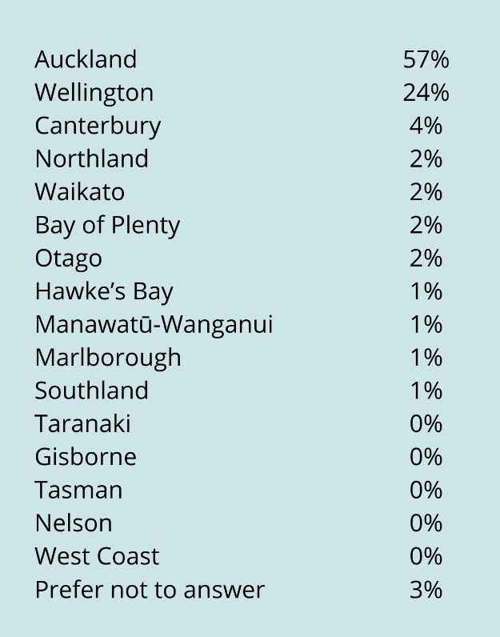

Ethnicity

Primary Role in the screen sector

Networking, connections and support
We asked a set of questions to understand how people actively keep in touch with what is happening in the sector, organisations they regularly engage with and whether they have a mentor to offer advice and support.
Word of mouth, social media and guilds or industry organisations were the top three ways people keep in touch with what is happening in the industry. The majority of respondents regularly engage with Women in Film and Television, Script to Screen, The Directors and Editors Guild and the NZ Writers Guild. These results are consistent with the membership numbers for the guilds.
Positive recognition for the work of screen sector guilds and organisations was clear, noting that they provide support for communities within the sector and have contributed to the advancement of opportunity and access in the industry.
“Organisations like Script to Screen and DEGNZ, WIFT and PASC are doing an amazing job of supporting their various sub-communities - and I love attending their events - which I do as often as I'm able.”
“I’ve noticed some positive changes, especially with the work being done by the Pan-Asian Screen Collective (PASC). They don’t just support—they actively fight for us, pushing for real change and demanding that our voices be heard.”
“There has been a definite move towards positive change with regards to genuine diversity and representation. This can be directly attributed to the work of PASC and PISA.”
“The 48 hr Film festival keeps just getting better and better - such a great thing to be able to participate in. And the guilds are running such great events and workshops - I find it a very stimulating environment + community.”

How do you keep in touch with what is happening in the sector?

What organisations do you regularly engage with?

Mentorship
34% of respondents have a mentor who provides support and advice in relation to their work. The most common mentors were experienced filmmakers, ex-colleagues and guilds and industry organisations. People who have mentors said they were generous with their time and often give advice on making industry connections, legal questions, self-advocating and generating work.
For the 66% of those who do not have a mentor, more than half would like to have one. Many people shared that finding a mentor can be difficult due to the time it takes to build networks, the limited number of people who are available to offer advice and the resources available (such as money and time). People who lived outside Auckland and Wellington were less likely to have a mentor.
“When you work primarily from home, it's difficult to build a network outside of events if you don't have a mentor or existing relationships in the industry who you regularly speak with.”
“Having a trusted online space to connect with likeminded people would be really helpful - that specifically encourages people to foster new professional relationships when you have not been to film school, etc.”
“There are a very limited number of mentors/ tutors willing to spend their time training new comers (even with them charging a large amount for their courses, not all are adequate or accessible for everyone)”

Do you actively connect with other people in the screen sector to discuss diversity, equity and inclusion?

What do you talk about?

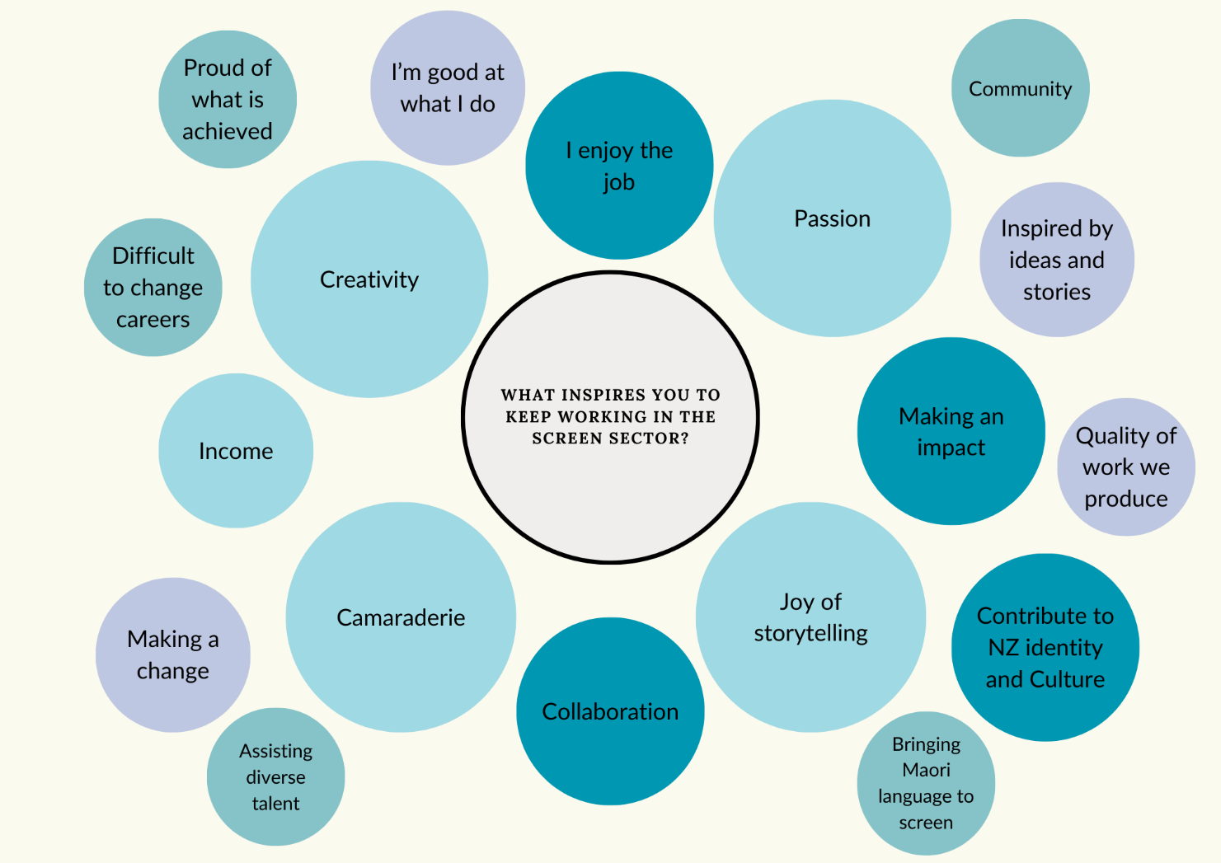

Making an impact

When asked, “what inspires you to keep working in the screen sector?” passion, the joy of storytelling, creativity and camaraderie were the top answers. People are proud of making an impact, contributing to New Zealand culture and identity and bringing our stories to screen.
“I love cinema and the process of making it with every fibre of my being. I think it's important that there are truly diverse voices heard, and that means people like me can't give up on our own work, even if we are doing it for love alongside a day job. I love collaborating with incredibly talented people and the beautiful experience of making something that can mean something to strangers.”
“As creatives we have the enormous capacity and ability to create worlds where Māori stories are valued, treasured and inspire our whanau.”
“I like the sense of camaraderie, especially on smaller productions. When a set is healthy, it's one of the most exciting and enriching workplaces. I'm also very passionate about keeping the NZ screen industry thriving. I think we've got something special here in Aotearoa, and I think it should be fostered!”
“Incredible creatives, telling important stories, uniquely of Aotearoa. The joy in knowing we are all contributing to our screen legacy, each and every day, making precious taonga for future generations and audiences around the world.”
“The tenacity, creativity, heart and talent of everyone working in the industry, even in the face of adversity. The problem-solving, rallying and inventiveness of my colleagues. The incredible mahi that comes out of this industry. The chance to be part of a sector that tells stories and starts conversations, that can educate, entertain and heal.”
“What inspires me to keep working in the screen sector is my love for storytelling and the opportunity to reflect my community on screen. It’s as simple as that. It’s certainly not about the money—it’s about creating meaningful stories that resonate with people.”

Barriers and Baises
To better understand what may be limiting people from progressing their career in the screen sector, we asked questions about barriers and biases. Across all respondents, economic limitations, the cost of professional training and parental responsibilities were the highest barriers to progression. An option was given to list other barriers, with location, networks and racism listed as the highest.
Have any of the following been barriers to you while working in the screen sector? (All respondents)

Other barriers noted
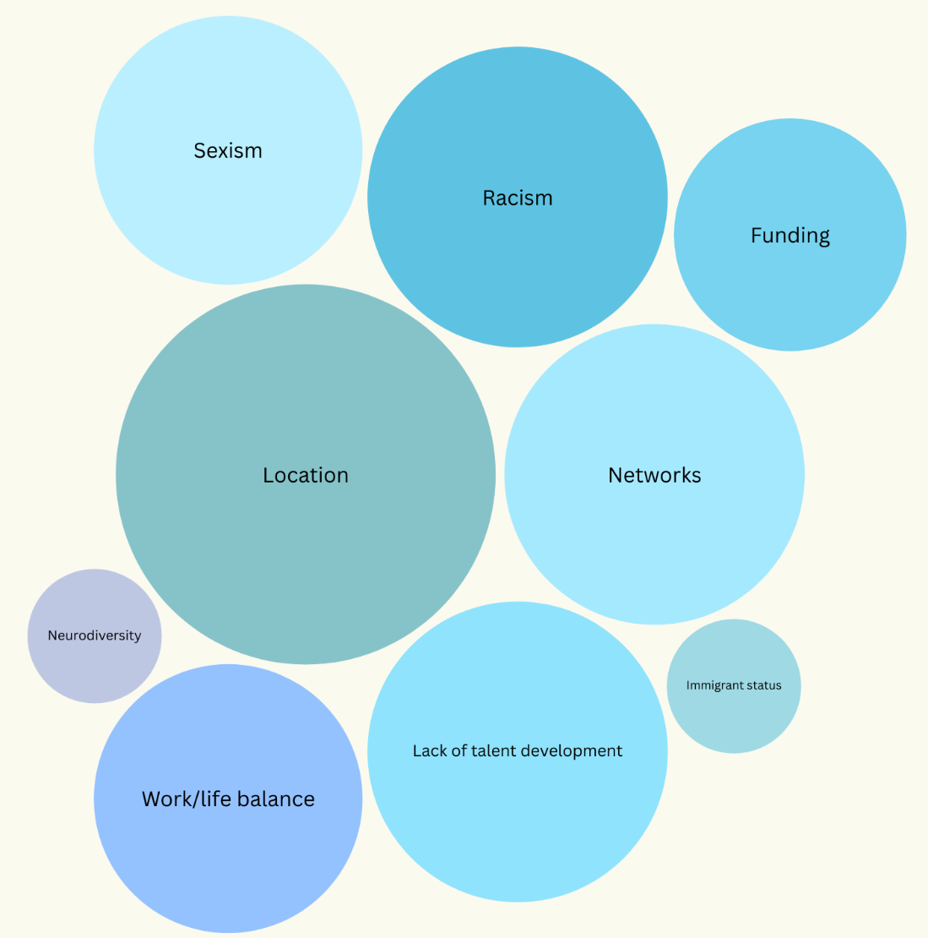

Gender and age bias were the most commonly experienced biases noted. Gender bias was more likely to be experienced by those who identify as gender diverse and female, ethnicity bias was more likely to be experienced by Asian peoples and age bias was more likely to be experienced by women.
Have you experienced any of the following biases while working in the screen sector? (All respondents)

Other biases noted
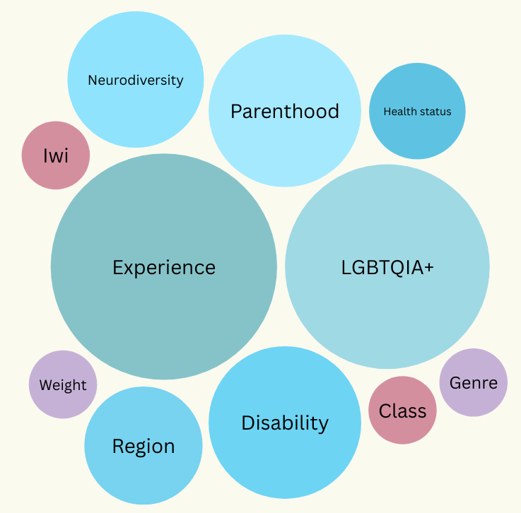

Economic limitations/Cost of Professional Training
Economic limitations were the highest barrier across all demographics and was reported significantly higher than when we conducted a similar survey in 2019, pre COVID-19. The cost of professional training was the second highest barrier across all respondents. The money required to upskill and financial stability were two common themes; training opportunities require money and time, which many people do not have.
“Often there will be conferences in membership costs (including travel) that will often be very cost prohibitive. Sometimes there will be travel grants and/or scholarships, but these are always limited so people will always miss out.”
“Economic barriers have sometimes stopped me from accessing the work site. This has been a temporary matter which lasts no more than two or three days. Cost of training has kept me on a low- ranking status in the industry, because I often do not opt for the training because of the price.”
“To be recognised and respected in the screen world you have to have training or work behind you. So you need the money to do that, to meet people in courses and collaborate.”
Another common theme was the conflict between financial stability and career progression. It was noted that people are working below the minimum wage and doing so out of passion, making it difficult to sustain and progress a career without adequate economic compensation.
“Not being paid enough for my work has caused me to cease pursuing that work or my development in that area and focus on other creative industry roles. One of the roles I do requiring way way way fewer skills, way less gear and way way way less training gets paid about 10 TIMES MORE than the role that I did/would like to do requiring years of experience, training, expensive gear etc. For 100 TIMES LESS the time involved.”
“Economic limitations - I'm not from a family with means to help support me in the early days of chasing a film&TV career. I've always had to juggle getting real paid work in order to survive, which makes it hard to focus fully on filmmaking and writing.”
“It is hard to have enough time, space, and money to be fully dedicated to career progression as an artist. This is particularly as a young Asian woman. It is almost impossible to have arts as the only source of income, it is insufficient and it feels like it's hard to acting to meet longer-term financial goals (e.g. buying a house, saving for retirement).”

Parental Responsibilities
Parental responsibilities were the third highest barrier for respondents, with this impacting female and Māori respondents at higher levels.
Experiences were shared about having to step back from work once people had children, or that they found it difficult to return to work after having children, impacting career development. This often resulted in parents having to “catch up,” take on less pay, smaller projects or wait until their children were older to return to the workforce. Opportunities for flexible working was suggested as a way to support parents, others said having private spaces on set to pump milk or childcare options would create greater access for parents.
“Being a single parent you can only work when you have support to care for kids. Due to the duration of a film day child care is cost prohibitive so you either don’t work and lose visibility in the industry making future work harder or you work for a huge financial loss to maintain visibility in the industry.”
“Since having a child it has been difficult to find well paid jobs with good hours that work around having a family. It Doesn’t feel like you can be a good mum and continue to grow a career due to the 10hr on set work days. So I’m at a stand still doing the work that I’m able to do with producers that are flexible to allow some work from home. I feel that until the kids are a lot older my career will plateau.”
“There have been several occasions when I have been asked in job interviews if I had any children. While this question seems friendly, it is also illegal to seek such information when considering a candidate for a job. Being honest and always positive, I have always answered this question. However, this led to a sudden retraction of a job offer as the employer didn't think I could "manage the pressure of having kids and the project".”
“I am a long-time freelancer, and I have seen how my female colleagues have had to struggle harder to maintain the same calibre of job offers after they had children. There is an immediate assumption that mothers are not as available and capable as fathers.”

Age

41% of participants have experienced age bias while working in the sector
When broken down, age bias was experienced at higher levels by women, with 47% of women experiencing age bias. Narrative responses show that ageism is experienced by both younger and older people, with those who are older feeling as though they are losing work and younger practitioners not taken as seriously by their colleagues.
“As an older person working in the development area, my ideas are often dismissed as being out of touch with and not of value to the younger audience who are seen as more important by broadcasters, platforms etc.”
“Since I turned 40, now the conversation has been about how limited my time is to "make it" (meaning I am almost past my expiry date), so I see my age playing a big part in my career as a creative, completely disregarding my experience, skill set and industry knowledge.”
“I’ve been told that at 38, I’m "too old" to change careers and that roles like Production Assistant or Production Coordinator are better suited for younger people.”
“Being young you have to convince others that you’re reliable and know how to work. But without a first role, or proof of that it’s almost impossible to be given a chance. But then when you’re older if you don’t have the body of work you’re supposed to have from when you were young, there is restrictions around that. Training is the best thing, but you have to have the resources for it.”
“Ageism is often looked at as 'someone older is discriminated against'. In my experience during my entire time in this industry, I have been treated according to my age, not according to my skill, experience, qualifications and success.”

Wellbeing
60% of respondents rated their mental health as “very good” or “good”. When we delve deeper into these responses, we can see that mental wellbeing is impacting those who identify as gender diverse, neurodiverse, disabled and LGBTQIA+ more than others.

Mental health and wellbeing is clearly intersectional, and often linked to other barriers such as economic limitations and financial stability. Some people shared that the loss of funding and redundancies across the sector, and low budgets for productions have had major impacts and a toll on mental health. People spoke of experiencing burnout due to long hours and a lack of work-life balance, consistent pay and routine.
“I was under so much stress trying to pull off a project with an insanely low budget that I ended up in hospital with burnout and I'm slowly recovering. This is not a one off, this is the result of having to do this cycle again and again for the past 10 years: overworking on stretched productions, burning out, then having no funds to live during the gap between jobs which creates significant stress.”
“Budgets are too low, so there is a human cost. It results in long working hours to get things done in impossible timeframes. Lack of work-life balance because you can't do anything but work.”
“I believe everyone is suffering more than they realise after the past few years - main issues being covid and the tightening of budgets in an ever-shrinking industry where it's a miracle to be working at all. But I know that I have had to work harder and achieve more visible and undeniable success in order to keep my place in this industry.”

Other people spoke to mental health initiatives “slipping through the cracks” and not being a priority when working with tight budgets, with individuals feeling responsible for their own mental health and wellbeing.
“As freelancers, we're often left to our own devices for mental health and well-being. Personally I think we're worked too hard, and our jobs can be incredibly tolling. Especially those in junior positions, working 10:45 5-6 days a week consistently while on a runners wage (10:45 is a dream day for a runner) it's not something we should be putting people through simply for the 'privilege' of working in the industry.”
“I feel our standards are slipping more toward the control of companies, and their wants, rather than the needs of individuals. The blue book being guidelines is not good enough, and a unionised industry IMO would be significantly better for the individuals in our industry.”
“Some of the workplaces I’ve been in such as my current workplace has great mental health support and safety regulations in place, for shorter shoots I’ve been on however often there’s a lot of health and safety measures that slip through the cracks.”
In addition to the financial pressures and work conditions in the industry, others shared experiences of discrimination and bullying that led to poor wellbeing and mental health.
“I had a panic attack from work related stress. I had to take a mental health break for 1 week. On another occasion, I was (low key) bullied by a colleague, which caused me so much stress, I had to take an unplanned overseas holiday to process, decompress and lift my spirits back up again.”
“In terms of the mental health related discrimination, when these situations of agesim and sexism arise in my workplace, understandably, it is incredibly triggering and upsetting. When I have been triggered and upset, I have not received support, I have received judgment.”
“On two separate occasions, women in positions of power did not allow me to negotiate the terms and conditions, and pay rate for my contract. I was talked down, and left both meetings feeling upset, voiceless and that the situation was beyond my control, and I had to accept their terms or risk losing my job.”

Region

Regional barriers was a key theme that emerged through the narrative responses in the survey. The majority of survey respondents were based in Auckland (57%) and Wellington (24%), meaning only 98 of respondents lived outside these main centres. Economic limitations was the highest barrier faced by all regions; however, we can see this is especially high for those living in Canterbury, with 71% saying economic limitations were a barrier in their career. Accessibility barriers were also higher for those living in the South Island.
“Clearly the focus on major population areas will always be greater than the regions - however more of NZ's screen income is derived from shooting within the regions for world class locations, so it would seem fair that more regional based opportunities are included in the future.”
“There are not enough internships, mentorships or other experiences available for people who are starting out, especially in the South Island.”
“It's very difficult for folks in Southern regions to network with decision-makers in Auckland. In addition, many training opportunities & conferences are only offered in-person in Christchurch. We're left out of the loop.”
“Many main centre opportunities, often provided free of charge, are unaffordable for regional based industry professionals when taking into account the cost of efficient travel options.”
“Most of the work is in Auckland. It is not practical for me to move my entire family to Auckland. As such, this has become a barrier to work.”
“The South Island needs to be taken seriously, not just as a location destination and a place for post-production and digital projects via the UC Digital Campus- it should also be given further opportunities to grow talent and provide tangible industry opportunities.”

Gender
61% of women have experienced gender bias. 82% of gender diverse participants have experienced gender bias. 23% of men have experienced gender bias

Women shared experiences of feeling belittled by male colleagues and not being taken as seriously as their male counterparts.
“I invited an experienced VFX professional to provide advice to a university, she was talked over and discounted by men in the room who were much older and had no experience with VFX, this was very eye opening about how I was being treated and had been treated in the past at other times and just didn't realise.”
“People often direct their questions/requests to my male colleagues despite me being in a senior position and having more experience. Particularly older male colleagues can be condescending.”
“As a younger-appearing woman I often find I'm talked over, interrupted and have to reiterate what I'm saying multiple times in order to be taken seriously. While it hasn't necessarily been a barrier to progress, it's draining and frustrating.”
Women also speak of experiences of unwanted advances and sexist comments from male colleagues, and this is currently happening in the industry, with comments ranging from what female talent are wearing, sexual harassment and jokes at the expense of women.
“As a younger women in the industry, earlier in my career, I experienced what was "normal" back then - unwanted sexual advances, rude jokes, unsafe workplaces. Myself and other women worked out quickly what the work arounds were in those environments. A lot of my female peers never made it, they went to other industries.”
“No matter the set it has been, older males (specifically DOPs, gaffers, grips etc) are always making jokes about the female talent, what they are wearing (or lack of it).”
“On set, being in a lower position I was sent around set to get signatures from department heads, I received sexist comments from men in high up positions. One also closing the door, and telling me to have a seat and a drink with him. I said I had to go and left. As a 21 year old female at the time, this being my first big set job in the industry, it was very difficult to feel safe. I told my immediate co workers, who suggested I don't say anything to be safe as the guy was a department head.”
“I have been bullied, belittled and experienced sexism working on on a 4 mill budget film in NZ. I do not feel safe or motivated to work in the NZ film industry after seeing how the heirachy is set up. The producers I worked with have an "us" and "them" mentality, and I was told by a producer on set sometimes they wanted to 'bend me over their knee.' This is in 2023. Recent history. I have worked all over the world and never experienced anything like it.”
Some of the male respondents soke to experiencing bias with the rise of equity and inclusion initiatives, with 23% of men saying they have experienced gender bias.
“There is now a perception that if you're a man, white, and a little older, that you're 'stale, pale, male'. It seems like this is the last prejudice that is acceptable.”
“As a middle aged, right handed heterosexual white man I am sometimes not considered for jobs/applications because I can't tick the diversity box. I often see crews that want people of every colour and creed, except for white, heterosexual males. Female, ethnically diverse, gay, trans are all welcomed. Essentially they are looking for 'anyone but a heterosexual white male'.”
“It's important to acknowledge that when answering this, it's only my perspective. Meaning even if I think I experienced bias, objectively that may not have been the case. In saying that, there are times when I sense there may have been some bias towards my gender (being male). I've entered into countless grants, programs, initiatives etc where there is limited placement. In the last few years when the results have come out, there is a trend of having far more woman chosen (60-70%) than men. I understand that for a long period of time the film industry was heavily male. But now it seems male generation of today is inheriting the consequences of biases from the generation before. We may have pushed too far in the other direction, and talent is losing out based on their gender.”

Māori
42% of Māori had experienced ethnicity bias, and the biggest barriers to working in the screen sector were economic limitations, parental responsibilities and the cost of professional training. The survey asked a series of questions asking how regularly participants had experienced certain barriers or comments. These questions were on a scale of regularly to never. Compared to other ethnic groups, Māori participants scored the highest in regularly experiencing racist, sexist, ableist, transphobic and ageist comments. They also reported the highest level of regularly experiencing bullying by both people in senior roles and colleagues.
“I've found being Māori the most difficult challenge in this industry. It seems like there are two extremes: 1) You're asked to be a part of a project because you are Māori first and foremost, regardless of your talent or if you're right for the job. It can feel like a tokenistic act to access funding. Suddenly you're the spokesperson for Māori on the project - which is a lot of pressure, given how intersectional the Māori community is. OR 2) You being Māori suddenly gives people permission to ask you to prove yourself, prove your brown-ness, your Māori-ness. You're measured by your skin colour and te reo level. Both of these experiences are off-putting. I don't think I want to make Māori films anymore.”
“The other thing I've seen happen a lot is younger Māori colleagues being asked to educate everybody or shoulder responsibility / make strategic suggestions based on cultural knowledge, without it being in their job description or in their pay grade.”
“I have been told my credit is not because of the work I have put in but because I am Māori. I have worked longer than my agreed contract, and when asked for compensation I have been told "no" - and yet there's an expectation on me to continue to engage in the work.”
“Being Māori in the industry and feeling like you have to constantly prove yourself to make work.”

There were suggestions for more understanding of Te Tiriti and te ao Māori to better support Māori practitioners working in the industry. This included Te Tiriti training and providing cultural leave, tangi leave and wānanga leave.
“Understanding Te Tiriti o Waitangi would be a great start and understanding that if people are honouring this fully as promised, then better understanding and action is possible for equity and inclusion and respect for all people is possible. Everyone has a right to be treated with respect and consideration for their needs.”
“The screen industry urgently needs to overhaul its structures to ensure true diversity, equity, and inclusion that respects Te Tiriti o Waitangi and centres tangata whenua. This involves prioritising Māori and Pasifika storytelling, supporting underrepresented voices, and hiring authentically across all roles.”
“Greater value, education and emphasis placed on matauranga Māori. If you’re going to use Māori to help establish authenticity in your business (especially those that use Māori stories) – think about tangible ways that businesses can reciprocate that respect. In essence, giving Māori who are actively leaned on for their matauranga options like cultural leave, proper tangi leave... wānanga leave. We need to keep our kete full if we’re going to bolster a businesses relationship with Ao Māori.”
“In terms of Te Ao Māori, I want to see that taonga is treated as taonga should be treated - and that those who are the creators/kaitiaki/originators of that taonga have the power to decide what happens with it, how it is represented etc.”

Ethnicity
When selecting data, respondents had the choice of selecting more than one ethnicity. For the purposes of reporting on the data, the survey company have grouped Ethnicity into New Zealand European, Māori, Asian people, Pacific Peoples, Other European and Other. We understand this grouping can erase the experiences of certain communities. It is here that the qualitative data is especially useful to contextualise and add further richness to the themes that come through in the quantitative data.
When looking at the barriers across ethnic groups, economic limitations stand out as a clear barrier for all groups, however, the cost of professional training seems to be a higher barrier for Asian peoples and parental responsibilities is a higher barrier for Māori respondents.
People spoke of feeling as though they need to prove themselves or work harder due to their ethnicity.
“Something that has surprised me working with Pan-Asian practitioners is meeting the expectation and demand for excellence. This is a barrier for a prolonged career in the industry.”
“Have been told personally by at least two separate senior industry figures on different occasions, including a senior figure related to an NZ screen funding agency, that due to my ethnic/gender identity I would potentially have to “work harder than some others” for support from those agencies.”
“Women of colour have to be 200x better than anybody else in order to be allowed to stick around, in order to be taken even slightly seriously. It’s ruined my mental health and it’s almost impossible to build it back up when I have to keep working. I am considering leaving the industry after my current project because I can’t see why I would continue to harm myself like this.”
“Being the only Asian in a white team does have its effects. The truth is that people are more comfortable with people who look like them. There are cultural differences with how people communicate and I find it difficult to insert myself into conversations. It hasn’t stopped me from pursuing a career in this industry, but it does make me wish there is more Asian representation.”

Others spoke of feelings of exclusion, being the only person of their ethnicity within the workplace. Some shared specific examples where comments were made at the expense of their ethnicity.
“I have experienced challenges in my roles that I believe are barriers to having a sustainable and prolonged career in the industry. As an entry level screen practitioner 15 years ago I was the only Asian in post production in the production companies I worked for, and opportunities to progress were given to my less qualified white male counterparts.”
“Someone at a networking event who was quite tipsy made several comments about my racial and ethnic background in a degrading manner. This was upon graduating from my undergraduate degree and they were very belittling and condescending throughout the entire conversation with myself and my peers.”
“I say this as the new graduate 17 years ago that failed to find like minded practitioners in a hostile industry. When I was working in post-production there were "token chinky" jokes at my expense; as the only Asian in the production I was not permitted to play the Asian victim in the a true crime reenactment because "Who cares? No one will even notice".”
“We can see that European kiwis are trying to be inclusive of people of colour. Despite this effort, they haven't fully understood us (maybe they never will) which leads to "inclusivity" approaches that becomes harmful instead eg. cultural appropriation, cultural ignorance and lots of micro-aggressions.”
“Instead of being inclusive for the sake of being inclusive, non-POCS should be more careful with their actions as good intentions do not always lead to good outcomes and educate themselves.”

Deaf, Disabled & Neurodivergent
13% of respondents identified as being disabled and 20% identified as neurodiverse. While these are relatively small sample sizes, themes of accessibility were consistently high in the responses.

Like all respondents, economic limitations was the highest barrier, followed by cost of professional training and accessibility barriers. Accessibility barriers were much higher for disabled and neurodiverse participants in comparison to the overall respondent average of 15%
“The problem is, that with dwindling budgets, this industry is forced to go with the cheapest way to make work, which means that a production might have to go with a non-accessible location, or privilege able-bodied cast and crew because there simply isn't the time, resource and infastructure to support disabled communities.”
“Nobody is actually doing anything to provide disability accomodations on set because if they have to, then you’re slowing the day down, then they’ll just replace you. And if you complain about it then you’ll be difficult to work with and they’ll blacklist you.”
“Access is hardly ever brought up, and it means that disabled people are locked out of being involved in these projects. I wish it was a more robust conversation which would determine choices made throughout the process, including things like shoot locations, scheduling in line with crip time, and health and safety.”

“Turn around of deadlines or audition tapes continue to limit people with access or neurodivergent needs to fully and meaningfully participate in work or auditions The extra cultural labour I bring to work not being remunerated puts a strain across my Hauora”
“Being autistic, I don't easily connect with others, especially when meeting for the first time, so it is difficult to make both a good first impression or long standing relationships with people who could help with career progression or job opportunities. Industry events offer require in-person gatherings which are again difficult with anxiety and other aspects of autism (eg communication and sensory issues).”
“As someone who is ADHD, I can experience heightened sensitivity, which can result in low wellbeing and mental health. I have tried to tell my colleagues and managers about this, and that there are different ways that feedback and training could be delivered to support me. Although there is interest in learning more about neurodiversity, there is no time or resources put into training or support for myself or other neurodiverse people I work with.”
One of the key themes that emerged was a lack of accommodations and access requirements on set. This has resulted in people missing out on development opportunities or making it harder for them to participate. There was a link between access and economic limitations, with productions being faced with smaller budgets and choosing to cut access.
“It can be more expensive to get the support needed such as booking interpreters onto film set as they are not under the tier level when it comes to working on film set. Even though, I have tried to educate people about it, its became more into the too hard basket. I think with funding such as short film funding or even full feature film funding, there is more money needed because of my needs compared to an able bodied crew, they don't need to cover funding for interpreters or even an access coordinator. so it does have some impact in my career.”
“Film sets are typically not well accommodated for physically disabled personnel, most particularly if they happen to be part of crew. The fast pace of environment also doesn't always help. I understand however that this is contextual, and good measurements can still be put into place if aware ahead of time.”
“My lived experience is that neurodiversity is not understood well enough. This is overall in society and not necessarily reflective of just a screen industry issue. While there's been a boon of chatter around it since covid, nothing actually has been done to better accomodate those who are neurodiverse and in particular, there is a huge lack of understanding of what being neurodiverse is actually like, what it entails. Given the anecdotal evidence that creative industries tend to have a higher amount of neurodiversity, hoping this will change over time.”
“I have for the time being paused my pursuit of a career in the industry until a policy for equity and inclusion which encompasses my neurodivergent description is written and put into practice. In one instance, when I told someone the reason for my medical treatment - it is a scientific word - I was called a derogatory name. Until there is a basic education of the higher directors and producers about the meaning of why I should keep this reason a confidential matter between me doctor and I, I do not want to put myself at risk by pursuing a career.”
“Issues like exploring accessibility for neurodivergent peoples, and what they can contribute to storytelling, have been a very low priority as understandably so. With the nature of the beast, there is an outpouring of fresh graduates year after year, while the number of work opportunities remain stagnant. This isn't to digress from the the neurodivergent issue, but there appears to be a certain mould you need to fit (those succesful in this space sharing similar characteristics). The lack of representation for people like us in the upper echelons of our industry (at least those openly neurodivergent) also promotes this air of exclusivity we feel.”
“Unless you have confirmed diagnosis, which costs substantial amount, it is extremely had to get support for any types of neurodiversity or other types of disability.”

LGBTQIA+

“I experienced a lot of negative comments when I was starting my career. I felt personally targeted because of my gender. When I spoke to a senior member of the team about being able to contribute more I was pushed back down the hierarchy chain. People have said "she only got the job because she's gay".”
“I include misogyny as homophobia because at it's core that what's homophobia is - extended misogyny. But have had many conversations with female counterparts that are paid less. As for homophobia it more so comes from the people at the very top. Either they don't want any queer content or they want the very tired cliche content. Multiple times have been told that it's just not financially viable, without even knowing what the story is. Then there is of course the casual homophobia from older people (mainly men) that just goes unchecked. Because this industry is so competitive people just let it slide.”

Workplace Environments
A set of questions in the survey asked respondents to rate how strongly they felt their current workplace was meeting different needs, and their experiences within the workplace.
We received valuable feedback on these questions, some of this feedback was that the questions were based on the respondent’s knowledge and experience of the specific areas being asked and that the responses may be skewed as many screen workers work in multiple employment situations over the course of the year or are sole-employed. This must be considered in analysing the results, and this is where narrative responses provide to be useful and add additional context.
We can see that workplaces are doing well at meeting the needs of a psychically safe environment and a culturally safe environment. Areas such as accessible environments for disabled communities, childcare support and mental health policies and initiatives scored lower.
“To be honest, the answer to all those questions really depends on the production. Some productions are absolute pits while others are fine on all accounts. Above the line creatives have so much power in how safe a set is. For me, across the board, there is zero consideration for parents/childcare on film sets. It sometimes exists for above the line creatives but I've never seen an option for crew.”
“I have answered these questions in relation to the wider entertainment industry, rather than my direct workplace.”

41% said they are seeing a positive change in relation to diversity, equity and inclusion in the sector, 8% said they did not see a positive change and the rest of the respondents had mixed views.
“I don't personally believe there are many changes that could realistically be made to make the screen sector more welcoming and safe for women, POC, etc. It would require a lot of bravery and joint action from all of us and I don't think our industry is ready to admit there's enough of a problem for that, as too many people are still benefitting from being in power and keeping others powerless.”
“Since I started I’m happy to report the culture slowly is changing. The dirty jokes aren’t around anymore. Young people are fine with speaking up about bad behaviour, and addressing it.”
“There is sometimes a feeling of unwelcome in predominantly pakeha-led film crews, but I've noticed that this has changed a lot over the years now. It's definitely gotten better.”
“The most common issues have been casual sexism and homophobia (comments, innuendo, assumptions), overt sexual harassment (more common than you'd think), economic disadvantage (traditionally 'female' roles in industry regularly paid significantly less than 'male' roles even when senior). This has been across many years, locations, companies and has been part of accepted culture. At times it has created extreme fatigue and missed opportunities, but have continued in career nonetheless. My sense is that some of this is improving due to recent industry steps and global focus - though not the economic side.”
“A 10 hour work day is considered standard across the industry. On top of that, contracts (particularly in post) always stipulate that "a reasonable amount of overtime is expected", without additional pay. I mean... 50 hours a week is not normal. Being expected to work more on top of that as required is extortionate. Editors are consistently expected these days to work with headphones. Desk and chair setups are almost always poorly set-up for extended periods of work. These are not healthy or reasonable work expectations and negatively impact people's physical and mental health.”
“Something needs to be done - funding more projects, changing the contractor system to support better employment security, or as simple as educating contractors (and employers) on how to manage a contractor lifestyle successfully in the screen industry for financial security, work-life balance and wellbeing.”
“Psychologically safe environment: Marked this low as I feel there is high bullying in this industry. Personalities that make being open about things difficult. Equal pay policies and action plans: In some areas I do believe it's hard to distinguish if this is possible. For example, for actors their rates also depend on their years of experience and what they bring to a production (which isn't related to gender). Transparency, openness and accountability: This ties in with psychologically safe environment. I don't believe the industry has fostered a safe environment for non judgemental discussions. Quite a few areas are quick to push blame to others, unnecessarily.”
“The policies flip flop. There is a community of people who are working hard to achieve some of these goals, but when it reaches upper management, it feels like lots of ideas that are bold are quashed. There is clearly a division between folk who want to make a change and the people who can make the change but are not willing or able to do so.”

Ways Forward
To provide some guidance and ways forward, we asked respondents what changes they would like to see in the industry. Employing diversity equity and inclusion, improved funding and more flexibility in the workplace were the top three suggestions. A number of people noted that diversity and inclusion is often focused on gender, ethnicity and hiring practices, when it is so much more than that – it encompasses accessibility, age, location, rainbow communities and neurodiversity.
Focus on inclusion was also highlighted, recognising that once underrepresented practitioners have entered the industry, the systems are not equitable, inclusive and therefore safe for them. It was suggested that we implement more educational resources, collect data and open up conversations to demonstrate the realities and complexities of diversity and inclusion.
“A better understanding of what diversity and inclusion means - it is not just about targeted funding, or hiring specific people into positions based on their identity. It is about wellbeing, flexible working policies, childcare support, opening up new ways of working, making sure everyone feels included in their workplace.”
“Lots of positive change for the more 'obvious' / high-profile focuses like race and gender, but not necessarily enough support for things like childcare or disabled / neurodiverse people.”
“While more diversity initiatives have undoubtedly invited more diverse practitioners into the industry, we are not safe and supported once we're in. It's a complete overhaul of attitudes and systems that needs to happen, and this requires a broader understanding of the biases that have built the systems to begin with.”
“I think there is a lot of wariness from many pakeha in the industry who don't understand and feel threatened, so I think it would be useful to have better discussions (or, even better - data) to show the realities to them as to why they should be trying to foster more diversity and equity. For example, getting men who are high up in our industry along to the WIFT awards could be a simple and great way to showcase all the incredible female talent in our industry who they are not necessarily even thinking of working with because of their lifelong working relationships with males in the industry.”
Suggestions on ways to improve funding processes, and opportunities for accessing funding came through in this section of the survey. The importance of funding for guilds and industry organisations was highlighted, noting that they are fundamental to ensuring the industry pushes for diversity, equity and inclusion.
“I also think now is the time to really focus on promoting and creating māori media/film/tv and more funding opportunities. think there needs to be more of a boost and targeted funding for minority groups.”
“More DEI the better! I want to see more projects and stories funded that represent minority communities. And have people whose stories are being represented, also then working on those projects.”
“It would be great if funding agencies could actually survey completed projects that they have funded and ask these questions then. Has the project been equitable amongst the ATL crew? Have the contracts been fair or exploitative? Has there been transparency?”
“More accessible advertisements for funding for Pacific and Māori funding opportunities, most of the young community don't even know these things are available to them or where to look for them or how to successfully gain funding for their projects.”
“Funding opportunities should have flexibility in the process. For example, requiring people to submit an unedited video talking about the concept can turn me off from even attempting to submit an idea because I know I will be awkward on camera. Or knowing that the process will involve in person workshops in another city is often so anxiety inducing that I won't apply.”
Responses also demonstrated a desire to tell more diverse stories that go beyond the struggles of marginalised communities.
“Diversity does not just mean to include diverse characters for representation. It also means to tell diverse stories. Currently, all the films that get funded from ethnic filmmakers is just about immigrant issues Which frankly has now been done to death and is kind of stereotypical . There is much more outside of an immigrant’s struggle to explore.”
“One thing that I find really irritating is the continued portrayal of Māori and Pacific people as thugs, criminals or working class. I'd like to see more portrayals of families, working professionals which have a range of ethnicities.”
“While I am seeing more opportunities for people who were historically disadvantaged and/or underrepresented, a lot of the opportunities require those individuals to make a project about their disadvantages. For example, a queer filmmaker may be more likely to get funding for a project that talks about their experience as a queer person in the world. I think the most important thing is getting disadvantaged people to have the opportunity to create stories in general - about whatever they want.”
Flexibility and accessibility in the workplace came through in clear, specific themes. Responses called for childcare support on set – specifically childcare facilities at sound stages, better support for parents around childcare and sick leave. Suggestions were also made to have flexible alternatives to working, including part-time roles. These suggestions were made in the context of parents, but also for those who are neurodivergent and to support mental health and wellbeing.
“More support around working less than shooting hours for parents - particularly if you are offset and in prep. I feel the hours that are insisted upon are not always reflected of the work that is needed - just a general expectation of this is what a working day is.”
“I would like it to become common practice to have multiple part time positions available, rather than expecting one person to do an entire job and have all the responsibility falling on them, and for the industry to ultimately work towards less working hours, for the sake of everyone’s health and safety. I would like contractors to have access to sick leave and personal scheduled leave.”
“More open discussion and flexibility around neurodiversity and everybody's different needs e.g. starting work at a time that suits your sleep cycle / lifestyle; flexible working hours/days; option of working from home; option of working in an office room rather than open planed office; reducing the stigma.”
“Loosening the existing framework and expectations around schedules and deadlines. Mental health issues that prevent someone from having boundless energy or always being available to operate at 100% are a fact of life for everyone, but most importantly those with neurodiverse brains or common issues like depression or burnout. As a producer I understand that keeping the train on the tracks is imperative for multiple legitimate reasons, but there needs to be a way for us to build more fluid and flexible timelines where people can move with the requirements of their brains and bodies, and that won't always fit into shooting blocks and 10 hour days and deadlines.”
There were suggestions for creating more accessible workplaces, with calls for all production sets to be built with different abilities in mind, pronouns in signatures, accessibility policies in workplaces and funding for closed captions and audio descriptions.
“More opportunities that account for things like social and communication difficulties. For example, talks and events could have an option to attend via zoom and enable people to participate via text chat etc.”
“Having accessible resources would really help me develop my skills, learn, and understand the industry/work flow more. It’s a barrier when all the resources are hidden behind paywalls.”
“More awareness of neurodivergent disabilities and how those disabilities present in individuals so that there is more understanding and advocacy within the industry, * friendly language around neurodiversity - “everyone is a little bit on the spectrum” is not friendly/aware language. It’s like saying to someone in a wheel chair “I need to use a wheel chair, every once and a while””
There was support for having specific roles on set that would support filmmakers across a range of areas and to advocate for cast and crew – this was linked with having no HR support on film production. These suggestions included specific roles such as Access Coordinators and Intimacy Coordinators. There were also calls for support networks outside of the workplace such as an independent hotline for crew to contact and a support network for complaints when dealing with issues as an independent contractor.
“More education and training is needed. Support for specialised roles on set - Access Coordinators, Wellbeing Coordinators, Intimacy Coordinators. These roles are so important and will open up a new realm of filmmaking. We need to get on board with what is the new global standard - these kinds of roles are just that!”
“A specific role created on every film set, regardless of who is on set on any given day, who's job it is to advocate for/on behalf of actors and crew in cases where their wellbeing isn't being taken seriously, provide a safe space for any cast or crew to go to with concerns about the mahi or their wellbeing, and be someone who has the power to call for a mandatory break for an actor's wellbeing.”
“More mandatory access coordinators, cultural advisors, diversity training programs and initiatives, mandatory education workshops on cultural safety, disability and neurodivergence for screen sector practitioners - particularly casting directors, directors, broadcasting companies and producers.”
“If we are to make changes eg. Access co-ordinators being a new role, like intimacy co-ordinators are now required. Diversity advisors to hold productions responsible.”
Another theme that came through strongly in the responses was the desire for more training and upskilling. This looked like calls for more training and education for people working in the industry, leadership and management training and supporting mentorships and upskilling workshops that provide the necessary foundations for long-term success.
“Leadership and management training at the highest level. Also, compulsory anti-bullying and harassment training for everyone in the sector. I know the guidelines are there for everyone to access, but these seem to be disregarded by most of the industry.”
“I’d like to see compulsory Professional Respect Workshops and Intimacy Coordinator training at film school level too, and for film school projects or community funded short films only green lit and funded if they have professional health and safety protocols in place.”
“Perhaps a regional film industry day where each RFO is funded to provide training or events within their region, or within a shared regional zone if the cost of funding every RFO was too high.”
“I would like to see more mentorship opportunities for those who are 10-15 years in the industry. I am in my mid 40s and really feel isolated in the sense that I've already proved myself 'successful', but I'd still like to grow and I don't see many routes towards that.”

If you have any questions or would like to discuss, please email
diversity.inclusion@nzfilm.co.nz

